Java Tutorial

Whole javatpoint (java tutorial) under single PDF 😅 (277 page)
generated with python weasyprint
Credit goes to Gunjan Nandy (https://github.com/gunjannandy),
Software Development Engineer at ServiceNow
All rights preserved.
-Rising Flare Community (Revision 3)
Our core Java programming tutorial is designed for students and working professionals. Java is an object-oriented, class-based, concurrent, secured and general-purpose computer-programming language. It is a widely used robust technology.

What is Java?
Java is a programming language and a platform. Java is a high level, robust, object-oriented and secure programming language.
Java was developed by Sun Microsystems (which is now the subsidiary of Oracle) in the year 1995. James Gosling is known as the father of Java. Before Java, its name was Oak. Since Oak was already a registered company, so James Gosling and his team changed the name from Oak to Java.
Platform: Any hardware or software environment in which a program runs, is known as a platform. Since Java has a runtime environment (JRE) and API, it is called a platform.

Java Example
Let's have a quick look at Java programming example. A detailed description of Hello Java example is available in next page.
Simple.java

class Simple{
public static void main(String args[]){


Test it Now

Application
According to Sun, 3 billion devices run Java. There are many devices where Java is currently used. Some of them are as follows:
- Desktop Applications such as acrobat reader, media player, antivirus, etc.
- Web Applications such as irctc.co.in, javatpoint.com, etc.
- Enterprise Applications such as banking applications.
- Mobile
- Embedded System
- Smart Card
- Robotics
- Games, etc.

Types of Java Applications
There are mainly 4 types of applications that can be created using Java programming:
- Standalone Application

Standalone applications are also known as desktop applications or window-based applications. These are traditional software that we need to install on every machine. Examples of standalone application are Media player, antivirus, etc.
AWT and Swing are used in Java for creating standalone applications.
- Web Application

An application that runs on the server side and creates a dynamic page is called a web application. Currently, Servlet, JSP, Struts, Spring, Hibernate, JSF, etc. technologies are used for creating web applications in Java.
- Enterprise Application

An application that is distributed in nature, such as banking applications, etc. is called an enterprise application. It has advantages like high-level security, load balancing, and clustering. In Java, EJB is used for creating enterprise applications.
- Mobile Application

An application which is created for mobile devices is called a mobile application. Currently, Android and Java ME are used for creating mobile applications.

Java Platforms / Editions
There are 4 platforms or editions of Java:
- Java SE (Java Standard Edition)

It is a Java programming platform. It includes Java programming APIs such as java.lang, java.io, java.net, java.util, java.sql, java.math etc. It includes core topics like OOPs, String, Regex, Exception, Inner classes, Multithreading, I/O Stream, Networking, AWT, Swing, Reflection, Collection, etc.
- Java EE (Java Enterprise Edition)

It is an enterprise platform that is mainly used to develop web and enterprise applications. It is built on top of the Java SE platform. It includes topics like Servlet, JSP, Web Services, EJB, JPA, etc.
- Java ME (Java Micro Edition)

It is a micro platform that is dedicated to mobile applications.
- JavaFX

It is used to develop rich internet applications. It uses a lightweight user interface API.

History of Java
The history of Java is very interesting. Java was originally designed for interactive television, but it was too advanced technology for the digital cable television industry at the time. The history of Java starts with the Green Team. Java team members (also known as Green Team), initiated this project to develop a language for digital devices such as set-top boxes, televisions, etc. However, it was best suited for internet programming. Later, Java technology was incorporated by Netscape.
The principles for creating Java programming were "Simple, Robust, Portable, Platform-independent, Secured, High Performance, Multithreaded, Architecture Neutral, Object-Oriented, Interpreted, and Dynamic". Java was developed by James Gosling, who is known as the father of Java, in 1995. James Gosling and his team members started the project in the early '90s.

Currently, Java is used in internet programming, mobile devices, games, e- business solutions, etc. Following are given significant points that describe the history of Java.
- James Gosling, Mike Sheridan, and Patrick Naughton initiated the Java language project in June 1991. The small team of sun engineers called Green Team.
- Initially it was designed for small, embedded systems in electronic appliances like set-top boxes.
- Firstly, it was called "Greentalk" by James Gosling, and the file extension was .gt.
- After that, it was called Oak and was developed as a part of the Green project.

Why Java was named as "Oak"?
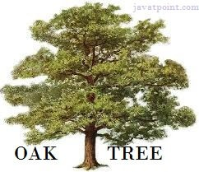
- Why Oak? Oak is a symbol of strength and chosen as a national tree of many countries like the U.S.A., France, Germany, Romania, etc.
- In 1995, Oak was renamed as "Java" because it was already a trademark by Oak Technologies.

Why Java Programming named "Java"?
- Why had they chose the name Java for Java language? The team gathered to choose a new name. The suggested words were "dynamic", "revolutionary", "Silk", "jolt", "DNA", etc. They wanted something that reflected the essence of the technology: revolutionary, dynamic, lively, cool, unique, and easy to spell, and fun to say.
According to James Gosling, "Java was one of the top choices along with Silk". Since Java was so unique, most of the team members preferred Java than other names.
- Java is an island in Indonesia where the first coffee was produced (called Java coffee). It is a kind of espresso bean. Java name was chosen by James Gosling while having a cup of coffee nearby his office.
- Notice that Java is just a name, not an acronym.
- Initially developed by James Gosling at Sun Microsystems (which is now a subsidiary of Oracle Corporation) and released in 1995.
- In 1995, Time magazine called Java one of the Ten Best Products of 1995.
- JDK 1.0 was released on January 23, 1996. After the first release of Java, there have been many additional features added to the language. Now Java is being used in Windows applications, Web applications, enterprise applications, mobile applications, cards, etc. Each new version adds new features in Java.

Java Version History

Many java versions have been released till now. The current stable release of Java is Java SE 10.
  - JDK Alpha and Beta (1995)
  - JDK 1.0 (23rd Jan 1996)
  - JDK 1.1 (19th Feb 1997)
  - J2SE 1.2 (8th Dec 1998)
  - J2SE 1.3 (8th May 2000)
  - J2SE 1.4 (6th Feb 2002)
  - J2SE 5.0 (30th Sep 2004)
  - Java SE 6 (11th Dec 2006)
  - Java SE 7 (28th July 2011)
  - Java SE 8 (18th Mar 2014)
  - Java SE 9 (21st Sep 2017)
  - Java SE 10 (20th Mar 2018)
  - Java SE 11 (September 2018)
  - Java SE 12 (March 2019)
  - Java SE 13 (September 2019)
  - Java SE 14 (Mar 2020)
  - Java SE 15 (September 2020)
  - Java SE 16 (Mar 2021)
  - Java SE 17 (September 2021)
  - Java SE 18 (to be released by March 2022)
Since Java SE 8 release, the Oracle corporation follows a pattern in which every even version is release in March month and an odd version released in September month.
More Details on Java Versions.

Features of Java
The primary objective of Java programming language creation was to make it portable, simple and secure programming language. Apart from this, there are also some excellent features which play an important role in the popularity of this language. The features of Java are also known as Java buzzwords.
A list of the most important features of the Java language is given below.
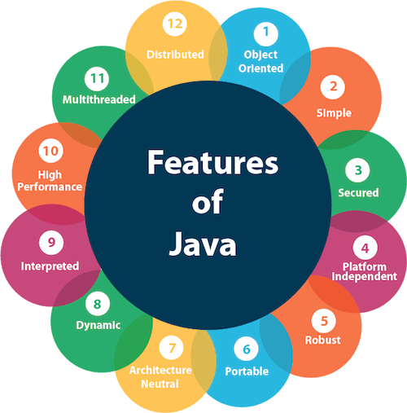

- Simple
- Object-Oriented
- Portable
- Platform independent
- Secured
- Robust
- Architecture neutral
- Interpreted
- High Performance
- Multithreaded
- Distributed
- Dynamic

Simple

Java is very easy to learn, and its syntax is simple, clean and easy to understand. According to Sun Microsystem, Java language is a simple programming language because:
  - Java syntax is based on C++ (so easier for programmers to learn it after C++).
  - Java has removed many complicated and rarely-used features, for example, explicit pointers, operator overloading, etc.
  - There is no need to remove unreferenced objects because there is an Automatic Garbage Collection in Java.

Object-oriented

Java is an object-oriented programming language. Everything in Java is an object. Object-oriented means we organize our software as a combination of different types of objects that incorporate both data and behavior.
Object-oriented programming (OOPs) is a methodology that simplifies software development and maintenance by providing some rules.
Basic concepts of OOPs are:
- Object
- Class
- Inheritance
- Polymorphism
- Abstraction
- Encapsulation

Platform Independent
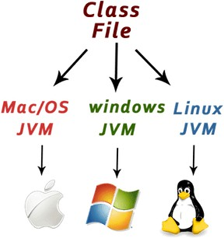
Java is platform independent because it is different from other languages like C, C++, etc. which are compiled into platform specific machines while Java is a write once, run anywhere language. A platform is the hardware or software environment in which a program runs.
There are two types of platforms software-based and hardware-based. Java provides a software-based platform.
The Java platform differs from most other platforms in the sense that it is a software-based platform that runs on top of other hardware-based platforms. It has two components:
- Runtime Environment
- API(Application Programming Interface)
Java code can be executed on multiple platforms, for example, Windows, Linux, Sun Solaris, Mac/OS, etc. Java code is compiled by the compiler and converted into bytecode. This bytecode is a platform-independent code because it can be run on multiple platforms, i.e., Write Once and Run Anywhere (WORA).

Secured

Java is best known for its security. With Java, we can develop virus-free systems. Java is secured because:
  - No explicit pointer
  - Java Programs run inside a virtual machine sandbox
how Java is secured
  - Classloader: Classloader in Java is a part of the Java Runtime Environment (JRE) which is used to load Java classes into the Java Virtual Machine dynamically. It adds security by separating the package for the classes of the local file system from those that are imported from network sources.
  - Bytecode Verifier: It checks the code fragments for illegal code that can violate access rights to objects.
  - Security Manager: It determines what resources a class can access such as reading and writing to the local disk.
Java language provides these securities by default. Some security can also be provided by an application developer explicitly through SSL, JAAS, Cryptography, etc.

Robust

The English mining of Robust is strong. Java is robust because:
  - It uses strong memory management.
  - There is a lack of pointers that avoids security problems.
  - Java provides automatic garbage collection which runs on the Java Virtual Machine to get rid of objects which are not being used by a Java application anymore.
  - There are exception handling and the type checking mechanism in Java. All these points make Java robust.

Architecture-neutral

Java is architecture neutral because there are no implementation dependent features, for example, the size of primitive types is fixed.
In C programming, int data type occupies 2 bytes of memory for 32-bit architecture and 4 bytes of memory for 64-bit architecture. However, it occupies 4 bytes of memory for both 32 and 64-bit architectures in Java.

Portable

Java is portable because it facilitates you to carry the Java bytecode to any platform. It doesn't require any implementation.

High-performance

Java is faster than other traditional interpreted programming languages because Java bytecode is "close" to native code. It is still a little bit slower than a compiled language (e.g., C++). Java is an interpreted language that is why it is slower than compiled languages, e.g., C, C++, etc.

Distributed

Java is distributed because it facilitates users to create distributed applications in Java. RMI and EJB are used for creating distributed applications. This feature of Java makes us able to access files by calling the methods from any machine on the internet.

Multi-threaded

A thread is like a separate program, executing concurrently. We can write Java programs that deal with many tasks at once by defining multiple threads. The main advantage of multi-threading is that it doesn't occupy memory for each thread. It shares a common memory area. Threads are important for multi-media, Web applications, etc.

Dynamic

Java is a dynamic language. It supports the dynamic loading of classes. It means classes are loaded on demand. It also supports functions from its native languages, i.e., C and C++.
Java supports dynamic compilation and automatic memory management (garbage collection).

C++ vs Java
There are many differences and similarities between the C++ programming language and Java. A list of top differences between C++ and Java are given below:
Comparison Index | C++ | Java
Platform- independent | C++ is platform- dependent. | Java is platform-independent.
Mainly used for | C++ is mainly used for system programming. | Java is mainly used for application programming. It is widely used in Windows-based, web-based, enterprise, and mobile applications.
Design Goal | C++ was designed for systems and applications programming. It was an extension of the C programming language. | Java was designed and created as an interpreter for printing systems but later extended as a support network computing. It was designed to be easy to use and accessible to a broader audience.
Goto | C++ supports the goto statement. | Java doesn't support the goto statement.
Multiple inheritance | C++ supports multiple inheritance. | Java doesn't support multiple inheritance through class. It can be achieved by using interfaces in java.
Operator Overloading | C++ supports operator overloading. | Java doesn't support operator overloading.
Pointers | C++ supports pointers. You can write a pointer program in C++. | Java supports pointer internally. However, you can't write the pointer program in java. It means java has restricted pointer support in java.

Compiler and Interpreter | C++ uses compiler only. C+  + is compiled and run using the compiler which converts source code into machine code so, C++ is platform dependent. | Java uses both compiler and interpreter. Java source code is converted into bytecode at compilation time. The interpreter executes this bytecode at runtime and produces output. Java is interpreted that is why it is platform-independent.
Call by Value and Call by reference | C++ supports both call by value and call by reference. | Java supports call by value only. There is no call by reference in java.
Structure and Union | C++ supports structures and unions. | Java doesn't support structures and unions.
Thread Support | C++ doesn't have built-in support for threads. It relies on third-party libraries for thread support. | Java has built-in thread support.
Documentation comment | C++ doesn't support documentation comments. | Java supports documentation comment (/** ... */) to create documentation for java source code.
Virtual Keyword | C++ supports virtual keyword so that we can decide whether or not to override a function. | Java has no virtual keyword. We can override all non-static methods by default. In other words, non-static methods are virtual by default.
unsigned right shift >>> | C++ doesn't support >>> operator. | Java supports unsigned right shift >>> operator that fills zero at the top for the negative numbers. For positive numbers, it works same like >> operator.

Inheritance Tree | C++ always creates a new inheritance tree. | Java always uses a single inheritance tree because all classes are the child of the Object class in Java. The Object class is the root of the inheritance tree in java.
Hardware | C++ is nearer to hardware. | Java is not so interactive with hardware.
Object-oriented | C++ is an object-oriented language. However, in the C language, a single root hierarchy is not possible. | Java is also an object-oriented language. However, everything (except fundamental types) is an object in Java. It is a single root hierarchy as everything gets derived from java.lang.Object.
Note

- Java doesn't support default arguments like C++.
- Java does not support header files like C++. Java uses the import keyword to include different classes and methods.

C++ Program Example
File: main.cpp

#include <iostream> using namespace std;
Output:

Hello C++ Programming

Java Program Example
File: Simple.java

class Simple{
public static void main(String args[]){
Output:

Hello Java

First Java Program | Hello World Example
In this section, we will learn how to write the simple program of Java. We can write a simple hello Java program easily after installing the JDK.
To create a simple Java program, you need to create a class that contains the main method. Let's understand the requirement first.

The requirement for Java Hello World Example

For executing any Java program, the following software or application must be properly installed.
- Install the JDK if you don't have installed it, download the JDK and install it.
- Set path of the jdk/bin directory. http://www.javatpoint.com/how-to-set-path- in-java
- Create the Java program
- Compile and run the Java program

Creating Hello World Example
Let's create the hello java program:

class Simple{
public static void main(String args[]){


Test it Now
Save the above file as Simple.java.
To compile: javac Simple.java
To execute: java Simple
Output:

Hello Java
Compilation Flow:
When we compile Java program using javac tool, the Java compiler converts the source code into byte code.
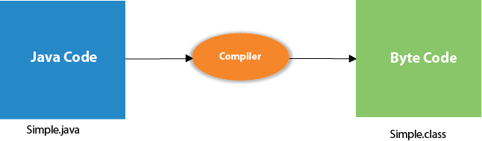

Parameters used in First Java Program
Let's see what is the meaning of class, public, static, void, main, String[], System.out.println().
- class keyword is used to declare a class in Java.
- public keyword is an access modifier that represents visibility. It means it is visible to all.
- static is a keyword. If we declare any method as static, it is known as the static method. The core advantage of the static method is that there is no need to create an object to invoke the static method. The main() method is executed by the JVM, so it doesn't require creating an object to invoke the main() method. So, it saves memory.
- void is the return type of the method. It means it doesn't return any value.
- main represents the starting point of the program.
- String[] args or String args[] is used for command line argument. We will discuss it in coming section.
- System.out.println() is used to print statement. Here, System is a class, out is an object of the PrintStream class, println() is a method of the PrintStream
class. We will discuss the internal working of System.out.println() statement in the coming section.

To write the simple program, you need to open notepad by start menu -> All Programs -> Accessories -> Notepad and write a simple program as we have shownbelow:
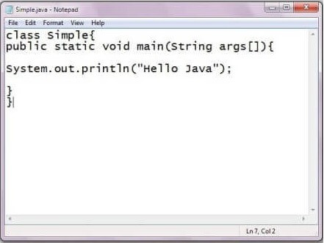
As displayed in the above diagram, write the simple program of Java in notepad and saved it as Simple.java. In order to compile and run the above program, you need to open the command prompt by start menu -> All Programs -> Accessories -
> command prompt. When we have done with all the steps properly, it shows the following output:
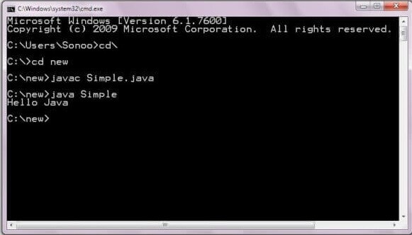
To compile and run the above program, go to your current directory first; my current directory is c:\new. Write here:
To compile: javac Simple.java
To execute: java Simple

In how many ways we can write a Java program?
There are many ways to write a Java program. The modifications that can be done in a Java program are given below:
- By changing the sequence of the modifiers, method prototype is not changed in Java.
Let's see the simple code of the main method.

static public void main(String args[])
- The subscript notation in the Java array can be used after type, before the variable or after the variable.
Let's see the different codes to write the main method.

public static void main(String[] args) public static void main(String []args)
- You can provide var-args support to the main() method by passing 3 ellipses (dots)
Let's see the simple code of using var-args in the main() method. We will learn about var-args later in the Java New Features chapter.

public static void main(String... args)
- Having a semicolon at the end of class is optional in Java.
Let's see the simple code.

class A{
static public void main(String... args){

Valid Java main() method signature

public static void main(String[] args) public static void main(String []args)

Invalid Java main() method signature

public void main(String[] args) static void main(String[] args)

Resolving an error "javac is not recognized as an internal or external command"?
If there occurs a problem like displayed in the below figure, you need to set a path. Since DOS doesn't recognize javac and java as internal or external command. To overcome this problem, we need to set a path. The path is not required in a case where you save your program inside the JDK/bin directory. However, it is an excellent approach to set the path. Click here for How to set path in java.
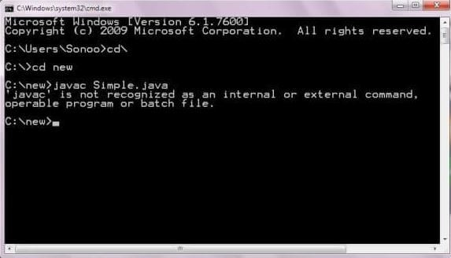

Internal Details of Hello Java Program
In the previous section, we have created Java Hello World program and learn how to compile and run a Java program. In this section, we are going to learn, what happens while we compile and run the Java program. Moreover, we will see some questions based on the first program.

What happens at compile time?
At compile time, the Java file is compiled by Java Compiler (It does not interact with OS) and converts the Java code into bytecode.


What happens at runtime?
At runtime, the following steps are performed:
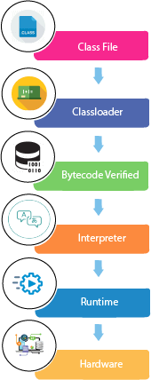
Classloader: It is the subsystem of JVM that is used to load class files.
Bytecode Verifier: Checks the code fragments for illegal code that can violate access rights to objects.
Interpreter: Read bytecode stream then execute the instructions.

Q) Can you save a Java source file by another name than the class name?
Yes, if the class is not public. It is explained in the figure given below:

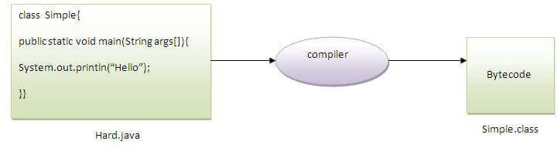

To compile: javac Hard.java
To execute: java Simple
Observe that, we have compiled the code with file name but running the program with class name. Therefore, we can save a Java program other than class name.

Can you have multiple classes in a java source file?

Yes, like the figure given below illustrates:
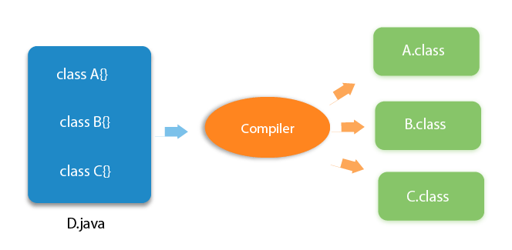

How to set path in Java
The path is required to be set for using tools such as javac, java, etc.
If you are saving the Java source file inside the JDK/bin directory, the path is not required to be set because all the tools will be available in the current directory.
However, if you have your Java file outside the JDK/bin folder, it is necessary to set the path of JDK.
There are two ways to set the path in Java:
  - Temporary
  - Permanent

How to set the Temporary Path of JDK in Windows
To set the temporary path of JDK, you need to follow the following steps:
  - Open the command prompt
  - Copy the path of the JDK/bin directory
  - Write in command prompt: set path=copied_path
For Example:

set path=C:\Program Files\Java\jdk1.6.0_23\bin
Let's see it in the figure given below:

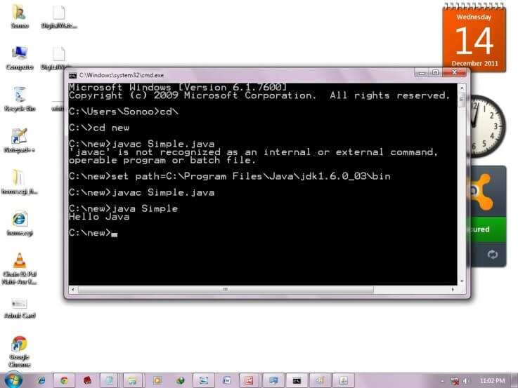

How to set Permanent Path of JDK in Windows
For setting the permanent path of JDK, you need to follow these steps:
  - Go to MyComputer properties -> advanced tab -> environment variables -> new tab of user variable -> write path in variable name -> write path of bin folder in variable value -> ok -> ok -> ok

For Example:

- Go to MyComputer properties


- Click on the advanced tab
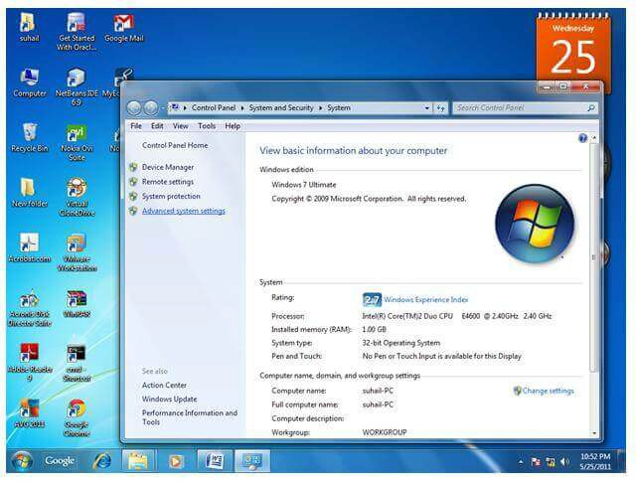

- Click on environment variables
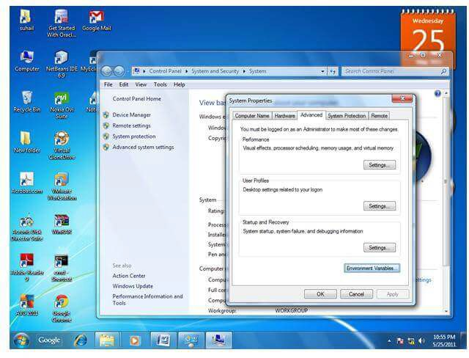
- Click on the new tab of user variables
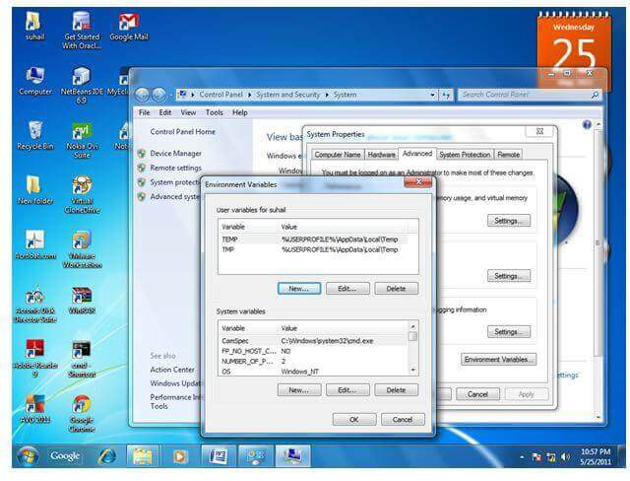
- Write the path in the variable name
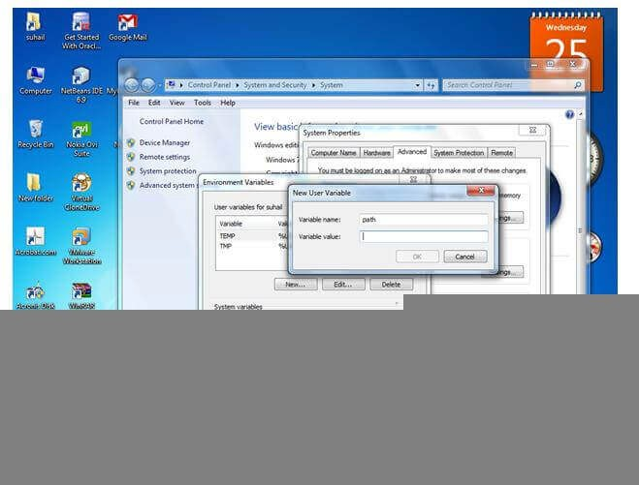
- Copy the path of bin folder
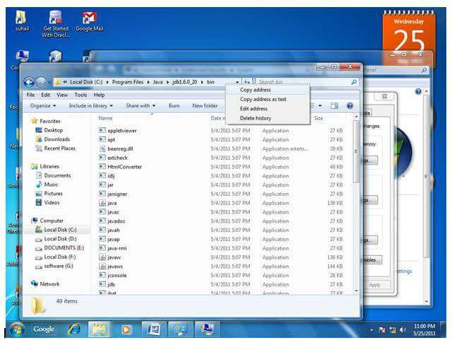

- Paste path of bin folder in the variable value
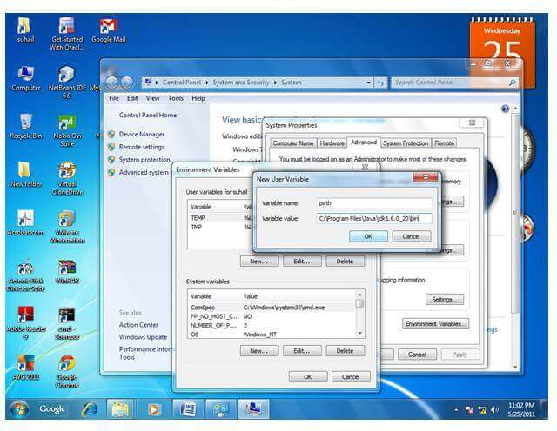
- Click on ok button
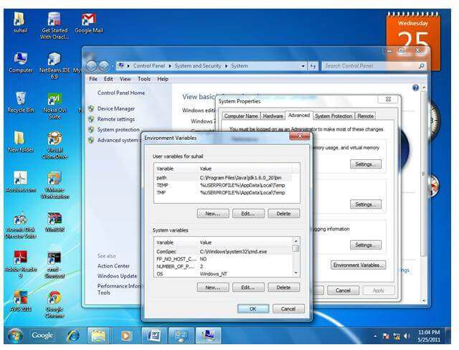
- Click on ok button
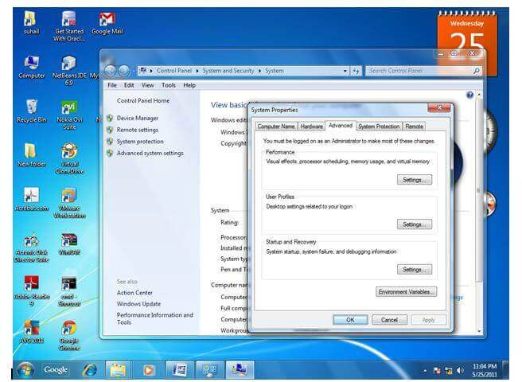

Now your permanent path is set. You can now execute any program of java from any drive.

Difference between JDK, JRE, and JVM
We must understand the differences between JDK, JRE, and JVM before proceeding further to Java. See the brief overview of JVM here.
If you want to get the detailed knowledge of Java Virtual Machine, move to the next page. Firstly, let's see the differences between the JDK, JRE, and JVM.

JVM

JVM (Java Virtual Machine) is an abstract machine. It is called a virtual machine because it doesn't physically exist. It is a specification that provides a runtime environment in which Java bytecode can be executed. It can also run those programs which are written in other languages and compiled to Java bytecode.
JVMs are available for many hardware and software platforms. JVM, JRE, and JDK are platform dependent because the configuration of each OS is different from each other. However, Java is platform independent. There are three notions of the JVM: specification, implementation, and instance.
The JVM performs the following main tasks:
- Loads code
- Verifies code
- Executes code
- Provides runtime environment More Details.

JRE

JRE is an acronym for Java Runtime Environment. It is also written as Java RTE. The Java Runtime Environment is a set of software tools which are used for developing Java applications. It is used to provide the runtime environment. It is the implementation of JVM. It physically exists. It contains a set of libraries + other files that JVM uses at runtime.
The implementation of JVM is also actively released by other companies besides Sun Micro Systems.
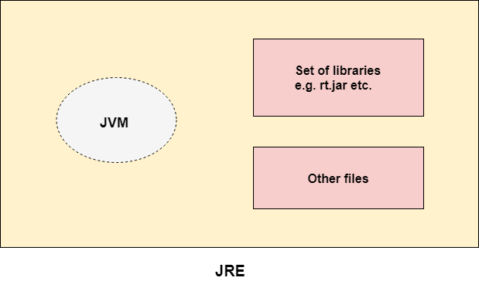

JVM (Java Virtual Machine) Architecture
JVM (Java Virtual Machine) is an abstract machine. It is a specification that provides runtime environment in which java bytecode can be executed.
JVMs are available for many hardware and software platforms (i.e. JVM is platform dependent).

What is JVM

It is:
  - A specification where working of Java Virtual Machine is specified. But implementation provider is independent to choose the algorithm. Its implementation has been provided by Oracle and other companies.
  - An implementation Its implementation is known as JRE (Java Runtime Environment).
  - Runtime Instance Whenever you write java command on the command prompt to run the java class, an instance of JVM is created.

What it does

The JVM performs following operation:
    - Loads code
    - Verifies code
    - Executes code
    - Provides runtime environment JVM provides definitions for the:
    - Memory area
    - Class file format
    - Register set
    - Garbage-collected heap
    - Fatal error reporting etc.

Java Variables
A variable is a container which holds the value while the Java program is executed. A variable is assigned with a data type.
Variable is a name of memory location. There are three types of variables in java: local, instance and static.
There are two types of data types in Java: primitive and non-primitive.

Variable
A variable is the name of a reserved area allocated in memory. In other words, it is a name of the memory location. It is a combination of "vary + able" which means its value can be changed.
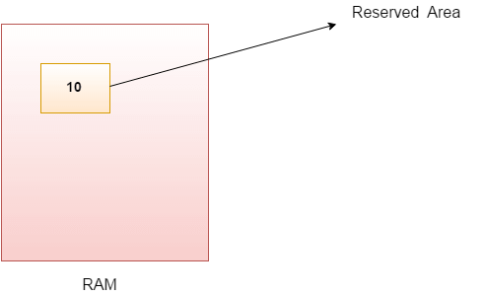

int data=50;//Here data is variable

Types of Variables

There are three types of variables in Java:
    - local variable
    - instance variable
    - static variable
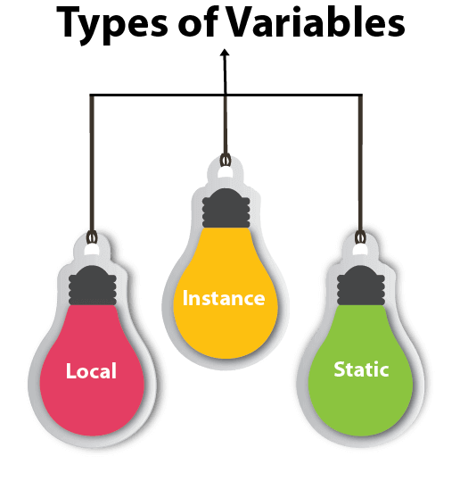

- Local Variable

A variable declared inside the body of the method is called local variable. You can use this variable only within that method and the other methods in the class aren't even aware that the variable exists.
A local variable cannot be defined with "static" keyword.
- Instance Variable

A variable declared inside the class but outside the body of the method, is called an instance variable. It is not declared as static.
It is called an instance variable because its value is instance-specific and is not shared among instances.
- Static variable

A variable that is declared as static is called a static variable. It cannot be local. You can create a single copy of the static variable and share it among all the instances of the class. Memory allocation for static variables happens only once when the class is loaded in the memory.

Example to understand the types of variables in java

public class A
{

Java Variable Example: Add Two Numbers

public class Simple{
public static void main(String[] args){
Output:

20

Java Variable Example: Widening

public class Simple{
public static void main(String[] args){
Output:

10
10.0

Java Variable Example: Narrowing (Typecasting)

public class Simple{
public static void main(String[] args){
Output:

10.5
10

Java Variable Example: Overflow

class Simple{
public static void main(String[] args){
Output:

130
-126

Java Variable Example: Adding Lower Type

class Simple{
public static void main(String[] args){
Output:

20

Data Types in Java
Data types specify the different sizes and values that can be stored in the variable. There are two types of data types in Java:
  - Primitive data types: The primitive data types include boolean, char, byte, short, int, long, float and double.
  - Non-primitive data types: The non-primitive data types include Classes, Interfaces, and Arrays.

Java Primitive Data Types
In Java language, primitive data types are the building blocks of data manipulation. These are the most basic data types available in Java language.


Java is a statically-typed programming language. It means, all variables must be declared before its use. That is why we need to declare variable's type and name.
There are 8 types of primitive data types:
    - boolean data type
    - byte data type
    - char data type
    - short data type
    - int data type
    - long data type
    - float data type
    - double data type
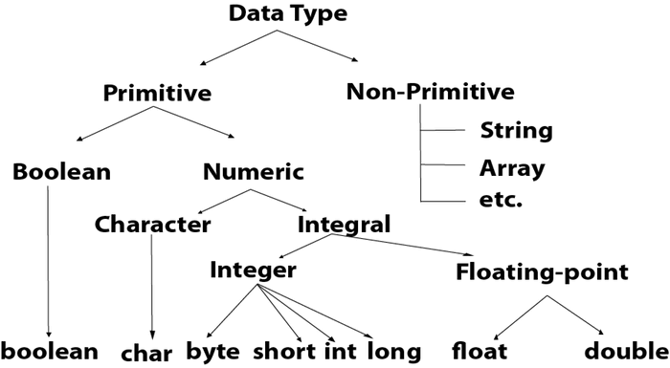
Data Type | Default Value | Default size
boolean | false | 1 bit
char | '\u0000' | 2 byte
byte | 0 | 1 byte
short | 0 | 2 byte
int | 0 | 4 byte
long | 0L | 8 byte
float | 0.0f | 4 byte
double | 0.0d | 8 byte

Boolean Data Type
The Boolean data type is used to store only two possible values: true and false. This data type is used for simple flags that track true/false conditions.
The Boolean data type specifies one bit of information, but its "size" can't be defined precisely.
Example:

Boolean one = false

Byte Data Type
The byte data type is an example of primitive data type. It isan 8-bit signed two's complement integer. Its value-range lies between -128 to 127 (inclusive). Its minimum value is -128 and maximum value is 127. Its default value is 0.
The byte data type is used to save memory in large arrays where the memory savings is most required. It saves space because a byte is 4 times smaller than an integer. It can also be used in place of "int" data type.
Example:

byte a = 10, byte b = -20

Short Data Type
The short data type is a 16-bit signed two's complement integer. Its value-range lies between -32,768 to 32,767 (inclusive). Its minimum value is -32,768 and maximum value is 32,767. Its default value is 0.
The short data type can also be used to save memory just like byte data type. A short data type is 2 times smaller than an integer.
Example:

short s = 10000, short r = -5000

Int Data Type
The int data type is a 32-bit signed two's complement integer. Its value-range lies between - 2,147,483,648 (-2^31) to 2,147,483,647 (2^31 -1) (inclusive). Its minimum value is - 2,147,483,648and maximum value is 2,147,483,647. Its default value is 0.
The int data type is generally used as a default data type for integral values unless if there is no problem about memory.
Example:

int a = 100000, int b = -200000

Long Data Type
The long data type is a 64-bit two's complement integer. Its value-range lies between -9,223,372,036,854,775,808(-2^63) to 9,223,372,036,854,775,807(2^63 -1)
(inclusive). Its minimum value is - 9,223,372,036,854,775,808and maximum value is 9,223,372,036,854,775,807. Its default value is 0. The long data type is used when you need a range of values more than those provided by int.
Example:

long a = 100000L, long b = -200000L

Float Data Type
The float data type is a single-precision 32-bit IEEE 754 floating point.Its value range is unlimited. It is recommended to use a float (instead of double) if you need to save memory in large arrays of floating point numbers. The float data type should never be used for precise values, such as currency. Its default value is 0.0F.
Example:

float f1 = 234.5f

Double Data Type
The double data type is a double-precision 64-bit IEEE 754 floating point. Its value range is unlimited. The double data type is generally used for decimal values just like float. The double data type also should never be used for precise values, such as currency. Its default value is 0.0d.
Example:

double d1 = 12.3

Char Data Type
The char data type is a single 16-bit Unicode character. Its value-range lies between '\u0000' (or 0) to '\uffff' (or 65,535 inclusive).The char data type is used to store characters.
Example:

char letterA = 'A'

Why char uses 2 byte in java and what is \u0000 ?

It is because java uses Unicode system not ASCII code system. The \u0000 is the lowest range of Unicode system. To get detail explanation about Unicode visit next page.

Unicode System
Unicode is a universal international standard character encoding that is capable of representing most of the world's written languages.

Why java uses Unicode System?

Before Unicode, there were many language standards:
- ASCII (American Standard Code for Information Interchange) for the United States.
- ISO 8859-1 for Western European Language.
- KOI-8 for Russian.
- GB18030 and BIG-5 for chinese, and so on.

Problem

This caused two problems:
- A particular code value corresponds to different letters in the various language standards.
- The encodings for languages with large character sets have variable length.Some common characters are encoded as single bytes, other require two or more byte.

Solution

To solve these problems, a new language standard was developed i.e. Unicode System.
In unicode, character holds 2 byte, so java also uses 2 byte for characters.
lowest value:\u0000 highest value:\uFFFF Operators in Java
Operator in Java is a symbol that is used to perform operations. For example: +, -,
*, / etc.
There are many types of operators in Java which are given below:
- Unary Operator,
- Arithmetic Operator,
- Shift Operator,
- Relational Operator,
- Bitwise Operator,
- Logical Operator,
- Ternary Operator and
- Assignment Operator.

Java Operator Precedence
Operator Type
Category
Precedence

Unary | postfix | expr++ | expr--
 | prefix | ++expr | --expr | +expr | -expr | ~ !
Arithmetic | multiplicative | * / %
 | additive | + -
Shift | shift | << >> >>>
Relational | comparison | < > <= >= instanceof
 | equality | == !=
Bitwise | bitwise AND | &
 | bitwise exclusive OR | ^
 | bitwise inclusive OR | |
Logical | logical AND | &&
 | logical OR | ||
Ternary | ternary | ? :
Assignment | assignment | = += -= *= /= %= &= ^= |= <<= >>=  >>>=

Java Unary Operator

The Java unary operators require only one operand. Unary operators are used to perform various operations i.e.:
- incrementing/decrementing a value by one
- negating an expression
- inverting the value of a boolean

Java Unary Operator Example: ++ and --

public class OperatorExample{ public static void main(String args[]){
Output:

10
12
12
10

Java Unary Operator Example 2: ++ and --

public class OperatorExample{ public static void main(String args[]){
Output:

22
21

Java Unary Operator Example: ~ and !

public class OperatorExample{ public static void main(String args[]){
Output:

-11
9
false true

Java Arithmetic Operators

Java arithmetic operators are used to perform addition, subtraction, multiplication, and division. They act as basic mathematical operations.

Java Arithmetic Operator Example

public class OperatorExample{ public static void main(String args[]){
Output:

15
5
50
2
0

Java Arithmetic Operator Example: Expression

public class OperatorExample{ public static void main(String args[]){
Output:

21

Java Left Shift Operator

The Java left shift operator << is used to shift all of the bits in a value to the left side of a specified number of times.

Java Left Shift Operator Example

public class OperatorExample{ public static void main(String args[]){

Output:

40
80
80
240

Java Right Shift Operator

The Java right shift operator >> is used to move the value of the left operand to right by the number of bits specified by the right operand.

Java Right Shift Operator Example

public OperatorExample{
public static void main(String args[]){
Output:

2
5
2

Java Shift Operator Example: >> vs >>>

public class OperatorExample{ public static void main(String args[]){
Output:

5
5
-5
1073741819

Java AND Operator Example: Logical && and Bitwise &

The logical && operator doesn't check the second condition if the first condition is false. It checks the second condition only if the first one is true.
The bitwise & operator always checks both conditions whether first condition is true or false.

public class OperatorExample{ public static void main(String args[]){
Output:

false false

Java AND Operator Example: Logical && vs Bitwise &

public class OperatorExample{ public static void main(String args[]){
Output:

false 10
false 11

Java OR Operator Example: Logical || and Bitwise |

The logical || operator doesn't check the second condition if the first condition is true. It checks the second condition only if the first one is false.
The bitwise | operator always checks both conditions whether first condition is true or false.

public class OperatorExample{ public static void main(String args[]){
Output:

true true true 10
true 11

Java Ternary Operator

Java Ternary operator is used as one line replacement for if-then-else statement and used a lot in Java programming. It is the only conditional operator which takes three operands.

Java Ternary Operator Example

public class OperatorExample{ public static void main(String args[]){
Output:

2
Another Example:

public class OperatorExample{ public static void main(String args[]){
Output:

5

Java Assignment Operator

Java assignment operator is one of the most common operators. It is used to assign the value on its right to the operand on its left.

Java Assignment Operator Example

public class OperatorExample{ public static void main(String args[]){
Output:

14
16

Java Assignment Operator Example

public class OperatorExample{ public static void main(String[] args){
Output:

13
9
18
9

Java Assignment Operator Example: Adding short

public class OperatorExample{ public static void main(String args[]){
Output:

Compile time error
After type cast:

public class OperatorExample{ public static void main(String args[]){
Output:

20

You may also like

Operator Shifting in Java

Java Keywords
Java keywords are also known as reserved words. Keywords are particular words that act as a key to a code. These are predefined words by Java so they cannot be used as a variable or object name or class name.

List of Java Keywords
A list of Java keywords or reserved words are given below:
- abstract: Java abstract keyword is used to declare an abstract class. An abstract class can provide the implementation of the interface. It can have abstract and non-abstract methods.
- boolean: Java boolean keyword is used to declare a variable as a boolean type. It can hold True and False values only.
- break: Java break keyword is used to break the loop or switch statement. It breaks the current flow of the program at specified conditions.
- byte: Java byte keyword is used to declare a variable that can hold 8-bit data values.
- case: Java case keyword is used with the switch statements to mark blocks of text.
- catch: Java catch keyword is used to catch the exceptions generated by try statements. It must be used after the try block only.
- char: Java char keyword is used to declare a variable that can hold unsigned 16-bit Unicode characters
- class: Java class keyword is used to declare a class.
- continue: Java continue keyword is used to continue the loop. It continues the current flow of the program and skips the remaining code at the specified condition.
- default: Java default keyword is used to specify the default block of code in a switch statement.
- do: Java do keyword is used in the control statement to declare a loop. It can iterate a part of the program several times.
- double: Java double keyword is used to declare a variable that can hold 64- bit floating-point number.
- else: Java else keyword is used to indicate the alternative branches in an if statement.
- enum: Java enum keyword is used to define a fixed set of constants. Enum constructors are always private or default.
- extends: Java extends keyword is used to indicate that a class is derived from another class or interface.
- final: Java final keyword is used to indicate that a variable holds a constant value. It is used with a variable. It is used to restrict the user from updating the value of the variable.
- finally: Java finally keyword indicates a block of code in a try-catch structure. This block is always executed whether an exception is handled or not.
- float: Java float keyword is used to declare a variable that can hold a 32-bit floating-point number.
- for: Java for keyword is used to start a for loop. It is used to execute a set of instructions/functions repeatedly when some condition becomes true. If the number of iteration is fixed, it is recommended to use for loop.
- if: Java if keyword tests the condition. It executes the if block if the condition is true.
- implements: Java implements keyword is used to implement an interface.
- import: Java import keyword makes classes and interfaces available and accessible to the current source code.
- instanceof: Java instanceof keyword is used to test whether the object is an instance of the specified class or implements an interface.
- int: Java int keyword is used to declare a variable that can hold a 32-bit signed integer.
- interface: Java interface keyword is used to declare an interface. It can have only abstract methods.
- long: Java long keyword is used to declare a variable that can hold a 64-bit integer.
- native: Java native keyword is used to specify that a method is implemented in native code using JNI (Java Native Interface).
- new: Java new keyword is used to create new objects.
- null: Java null keyword is used to indicate that a reference does not refer to anything. It removes the garbage value.
- package: Java package keyword is used to declare a Java package that includes the classes.
- private: Java private keyword is an access modifier. It is used to indicate that a method or variable may be accessed only in the class in which it is declared.
- protected: Java protected keyword is an access modifier. It can be accessible within the package and outside the package but through inheritance only. It can't be applied with the class.
- public: Java public keyword is an access modifier. It is used to indicate that an item is accessible anywhere. It has the widest scope among all other modifiers.
- return: Java return keyword is used to return from a method when its execution is complete.
- short: Java short keyword is used to declare a variable that can hold a 16-bit integer.
- static: Java static keyword is used to indicate that a variable or method is a class method. The static keyword in Java is mainly used for memory management.
- strictfp: Java strictfp is used to restrict the floating-point calculations to ensure portability.
- super: Java super keyword is a reference variable that is used to refer to parent class objects. It can be used to invoke the immediate parent class method.
- switch: The Java switch keyword contains a switch statement that executes code based on test value. The switch statement tests the equality of a variable against multiple values.
- synchronized: Java synchronized keyword is used to specify the critical sections or methods in multithreaded code.
- this: Java this keyword can be used to refer the current object in a method or constructor.
- throw: The Java throw keyword is used to explicitly throw an exception. The throw keyword is mainly used to throw custom exceptions. It is followed by an instance.
- throws: The Java throws keyword is used to declare an exception. Checked exceptions can be propagated with throws.
- transient: Java transient keyword is used in serialization. If you define any data member as transient, it will not be serialized.
- try: Java try keyword is used to start a block of code that will be tested for exceptions. The try block must be followed by either catch or finally block.
- void: Java void keyword is used to specify that a method does not have a return value.
- volatile: Java volatile keyword is used to indicate that a variable may change asynchronously.
- while: Java while keyword is used to start a while loop. This loop iterates a part of the program several times. If the number of iteration is not fixed, it is recommended to use the while loop.

Java Control Statements | Control Flow in Java
Java compiler executes the code from top to bottom. The statements in the code are executed according to the order in which they appear. However, Java provides statements that can be used to control the flow of Java code. Such statements are called control flow statements. It is one of the fundamental features of Java, which provides a smooth flow of program.
Java provides three types of control flow statements.
- Decision Making statements
  - if statements
  - switch statement
- Loop statements
  - do while loop
  - while loop
  - for loop
  - for-each loop
- Jump statements
  - break statement
  - continue statement

Decision-Making statements:

As the name suggests, decision-making statements decide which statement to execute and when. Decision-making statements evaluate the Boolean expression and control the program flow depending upon the result of the condition provided. There are two types of decision-making statements in Java, i.e., If statement and switch statement.

If Statement:

In Java, the "if" statement is used to evaluate a condition. The control of the program is diverted depending upon the specific condition. The condition of the If statement gives a Boolean value, either true or false. In Java, there are four types of if-statements given below.
  - Simple if statement
  - if-else statement
  - if-else-if ladder
  - Nested if-statement
Let's understand the if-statements one by one.
- Simple if statement:

It is the most basic statement among all control flow statements in Java. It evaluates a Boolean expression and enables the program to enter a block of code if the expression evaluates to true.
Syntax of if statement is given below.

if(condition) {
statement 1; //executes when condition is
Consider the following example in which we have used the if statement in the java code.
Student.java
Student.java

public class Student {
public static void main(String[] args) {
Output:

x + y is greater than 20
- if-else statement

The if-else statement is an extension to the if-statement, which uses another block of code, i.e., else block. The else block is executed if the condition of the if-block is evaluated as false.
Syntax:

if(condition) {
statement 1; //executes when condition is
Consider the following example.
Student.java

public class Student {
public static void main(String[] args) {
Output:

x + y is greater than 20
- if-else-if ladder:

The if-else-if statement contains the if-statement followed by multiple else-if statements. In other words, we can say that it is the chain of if-else statements that create a decision tree where the program may enter in the block of code where the condition is true. We can also define an else statement at the end of the chain.
Syntax of if-else-if statement is given below.

if(condition 1) {
statement 1; //executes when condition 1
Consider the following example.
Student.java

public class Student {
public static void main(String[] args) {
Output:

Delhi
- Nested if-statement

In nested if-statements, the if statement can contain a if or if-else statement inside another if or else-if statement.
Syntax of Nested if-statement is given below.

if(condition 1) {
statement 1; //executes when condition 1
Consider the following example.
Student.java

public class Student {
public static void main(String[] args) {
Output:

Delhi

Switch Statement:

In Java, Switch statements are similar to if-else-if statements. The switch statement contains multiple blocks of code called cases and a single case is executed based on the variable which is being switched. The switch statement is easier to use instead of if-else-if statements. It also enhances the readability of the program.
Points to be noted about switch statement:
- The case variables can be int, short, byte, char, or enumeration. String type is also supported since version 7 of Java
- Cases cannot be duplicate
- Default statement is executed when any of the case doesn't match the value of expression. It is optional.
- Break statement terminates the switch block when the condition is satisfied. It is optional, if not used, next case is executed.
- While using switch statements, we must notice that the case expression will be of the same type as the variable. However, it will also be a constant value.
The syntax to use the switch statement is given below.

switch (expression){ case value1:
Consider the following example to understand the flow of the switch statement.
Student.java

public class Student implements Cloneable {
Output:

2
While using switch statements, we must notice that the case expression will be of the same type as the variable. However, it will also be a constant value. The switch permits only int, string, and Enum type variables to be used.

Loop Statements

In programming, sometimes we need to execute the block of code repeatedly while some condition evaluates to true. However, loop statements are used to execute the set of instructions in a repeated order. The execution of the set of instructions depends upon a particular condition.
In Java, we have three types of loops that execute similarly. However, there are differences in their syntax and condition checking time.
- for loop
- while loop
- do-while loop
Let's understand the loop statements one by one.

Java for loop

In Java, for loop is similar to C and C++. It enables us to initialize the loop variable, check the condition, and increment/decrement in a single line of code. We use the for loop only when we exactly know the number of times, we want to execute the block of code.

for(initialization, condition, increment/ decrement) {
The flow chart for the for-loop is given below.
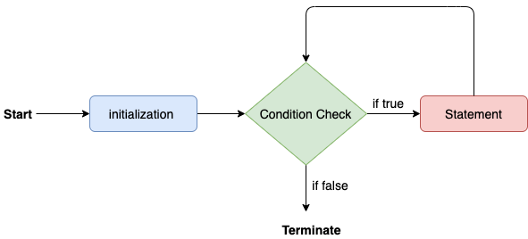
Consider the following example to understand the proper functioning of the for loop in java.
Calculation.java

public class Calculattion {
public static void main(String[] args) {
Output:

The sum of first 10 natural numbers is 55

Java for-each loop

Java provides an enhanced for loop to traverse the data structures like array or collection. In the for-each loop, we don't need to update the loop variable. The syntax to use the for-each loop in java is given below.

for(data_type var : array_name/ collection_name){
Consider the following example to understand the functioning of the for-each loop in Java.
Calculation.java

public class Calculation {
public static void main(String[] args) {
Output:

Printing the content of the array names:

Java C C++
Python JavaScript

Java while loop

The while loop is also used to iterate over the number of statements multiple times. However, if we don't know the number of iterations in advance, it is recommended to use a while loop. Unlike for loop, the initialization and increment/decrement doesn't take place inside the loop statement in while loop.
It is also known as the entry-controlled loop since the condition is checked at the start of the loop. If the condition is true, then the loop body will be executed; otherwise, the statements after the loop will be executed.
The syntax of the while loop is given below.

while(condition){
//looping statements
The flow chart for the while loop is given in the following image.
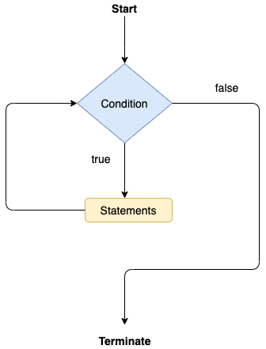
Consider the following example.
Calculation .java

public class Calculation {
public static void main(String[] args) {
Output:

Printing the list of first 10 even numbers

0
2
4
6
8
10

Java do-while loop

The do-while loop checks the condition at the end of the loop after executing the loop statements. When the number of iteration is not known and we have to execute the loop at least once, we can use do-while loop.
It is also known as the exit-controlled loop since the condition is not checked in advance. The syntax of the do-while loop is given below.

do
{
The flow chart of the do-while loop is given in the following image.
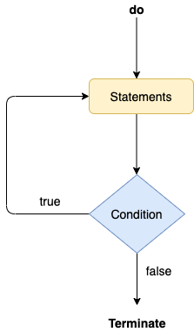
Consider the following example to understand the functioning of the do-while loop in Java.
Calculation.java

public class Calculation {
public static void main(String[] args) {
Output:

Printing the list of first 10 even numbers 0
2
4
6
8
10

Jump Statements

Jump statements are used to transfer the control of the program to the specific statements. In other words, jump statements transfer the execution control to the other part of the program. There are two types of jump statements in Java, i.e., break and continue.

Java break statement

As the name suggests, the break statement is used to break the current flow of the program and transfer the control to the next statement outside a loop or switch statement. However, it breaks only the inner loop in the case of the nested loop.
The break statement cannot be used independently in the Java program, i.e., it can only be written inside the loop or switch statement.
The break statement example with for loop
Consider the following example in which we have used the break statement with the for loop.
BreakExample.java

public class BreakExample {
Output:

0
1
2
3
4
5
6
break statement example with labeled for loop Calculation.java

public class Calculation {
Output:

0
1
2
3
4
5

Java continue statement

Unlike break statement, the continue statement doesn't break the loop, whereas, it skips the specific part of the loop and jumps to the next iteration of the loop immediately.
Consider the following example to understand the functioning of the continue statement in Java.

public class ContinueExample {
Output:

0
1
2
3
5
1
2
3
5
2
3
5

Java If-else Statement
The Java if statement is used to test the condition. It checks boolean condition: true
or false. There are various types of if statement in Java.
- if statement
- if-else statement
- if-else-if ladder
- nested if statement

Java if Statement
The Java if statement tests the condition. It executes the if block if condition is true.
Syntax:

if(condition){
//code to be executed

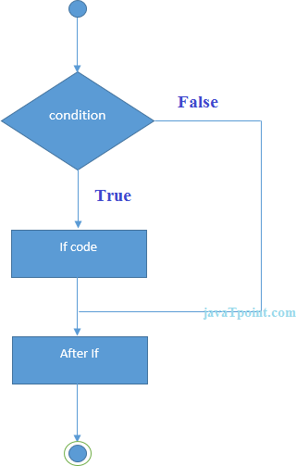

Example:

//Java Program to demonstate the use of if statement.


Test it Now
Output:
Age is greater than 18

Java if-else Statement
The Java if-else statement also tests the condition. It executes the if block if condition is true otherwise else block is executed.
Syntax:

if(condition){
//code if condition is true

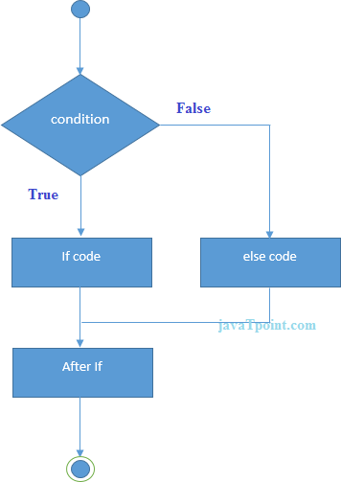

Example:

//A Java Program to demonstrate the use of if-else statement.


Test it Now
Output:
odd number
Leap Year Example:A year is leap, if it is divisible by 4 and 400. But, not by 100.

public class LeapYearExample { public static void main(String[] args) {
Output:
LEAP YEAR

Using Ternary Operator
We can also use ternary operator (? :) to perform the task of if...else statement. It is a shorthand way to check the condition. If the condition is true, the result of ? is returned. But, if the condition is false, the result of : is returned.
Example:

public class IfElseTernaryExample { public static void main(String[] args) {
Output:
odd number

Java if-else-if ladder Statement
The if-else-if ladder statement executes one condition from multiple statements.
Syntax:

if(condition1){
//code to be executed if condition1 is true

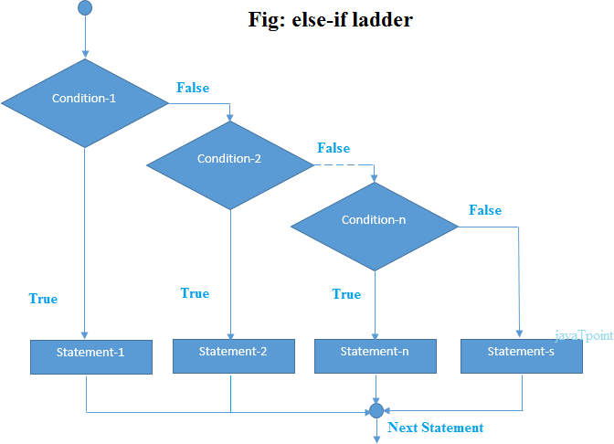

Example:

//Java Program to demonstrate the use of If else-if ladder.
Output:
C grade
Program to check POSITIVE, NEGATIVE or ZERO:

public class PositiveNegativeExample { public static void main(String[] args) {
Output:
NEGATIVE

Java Nested if statement
The nested if statement represents the if block within another if block. Here, the inner if block condition executes only when outer if block condition is true.
Syntax:

if(condition){
//code to be executed
Java Nested If Statement
Example:

//Java Program to demonstrate the use of Nested If Statement.


Test it Now
Output:
You are eligible to donate blood
Example 2:

//Java Program to demonstrate the use of Nested If Statement.


Test it Now
Output:

Java Switch Statement
You are not eligible to donate blood
The Java switch statement executes one statement from multiple conditions. It is like if-else-if ladder statement. The switch statement works with byte, short, int, long, enum types, String and some wrapper types like Byte, Short, Int, and Long. Since Java 7, you can use strings in the switch statement.
In other words, the switch statement tests the equality of a variable against multiple values.

Points to Remember

- There can be one or N number of case values for a switch expression.
- The case value must be of switch expression type only. The case value must be literal or constant. It doesn't allow variables.
- The case values must be unique. In case of duplicate value, it renders compile-time error.
- The Java switch expression must be of byte, short, int, long (with its Wrapper type), enums and string.
- Each case statement can have a break statement which is optional. When control reaches to the break statement, it jumps the control after the switch expression. If a break statement is not found, it executes the next case.
- The case value can have a default label which is optional.

Syntax:

switch(expression){ case value1:
Flowchart of Switch Statement flow of switch statement in java Example:
SwitchExample.java

public class SwitchExample {
public static void main(String[] args) {


Test it Now
Output:

20
Finding Month Example: SwitchMonthExample.javaHTML
//Java Program to demonstrate the example of Switch statement

Test it Now
Output:

7 - July
Program to check Vowel or Consonant:
If the character is A, E, I, O, or U, it is vowel otherwise consonant. It is not case- sensitive.
SwitchVowelExample.java

public class SwitchVowelExample { public static void main(String[] args) {
Output:

Vowel

Java Switch Statement is fall-through
The Java switch statement is fall-through. It means it executes all statements after the first match if a break statement is not present.
Example:
SwitchExample2.java

//Java Switch Example where we are omitting the


Test it Now
Output:

20
30
Not in 10, 20 or 30

Java Switch Statement with String
Java allows us to use strings in switch expression since Java SE 7. The case statement should be string literal.
Example: SwitchStringExample.java
//Java Program to demonstrate the use of Java Switch


Test it Now
Output:

Java Nested Switch Statement
We can use switch statement inside other switch statement in Java. It is known as nested switch statement.
Example: NestedSwitchExample.java

//Java Program to demonstrate the use of Java Nested Switch


Test it Now
Output:

Data Communication and Networks, MultiMedia

Java Enum in Switch Statement
Java allows us to use enum in switch statement. Java enum is a class that represent the group of constants. (immutable such as final variables). We use the keyword enum and put the constants in curly braces separated by comma.
Example: JavaSwitchEnumExample.java
//Java Program to demonstrate the use of Enum

Test it Now
Output:

Java Wrapper in Switch Statement
Java allows us to use four wrapper classes: Byte, Short, Integer and Long in switch statement.
Example:
WrapperInSwitchCaseExample.java

//Java Program to demonstrate the use of Wrapper class


Test it Now
Output:

You are eligible for vote.

Loops in Java
The Java for loop is used to iterate a part of the program several times. If the number of iteration is fixed, it is recommended to use for loop.
There are three types of for loops in Java.
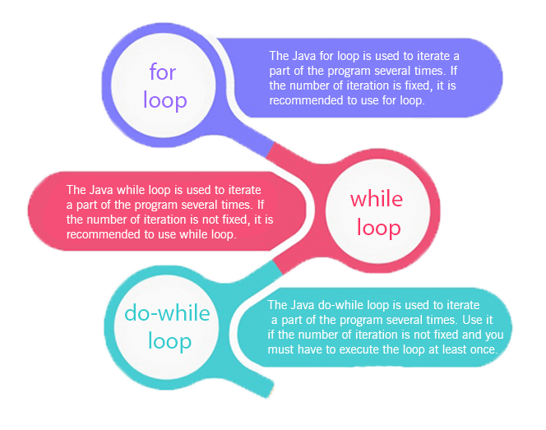

- Simple for Loop
- For-each or Enhanced for Loop
- Labeled for Loop

Java Simple for Loop
A simple for loop is the same as C/C++. We can initialize the variable, check condition and increment/decrement value. It consists of four parts:
- Initialization: It is the initial condition which is executed once when the loop starts. Here, we can initialize the variable, or we can use an already initialized variable. It is an optional condition.
- Condition: It is the second condition which is executed each time to test the condition of the loop. It continues execution until the condition is false. It must return boolean value either true or false. It is an optional condition.
- Increment/Decrement: It increments or decrements the variable value. It is an optional condition.
- Statement: The statement of the loop is executed each time until the second condition is false.
Syntax:

for(initialization; condition; increment/ decrement){
Flowchart:
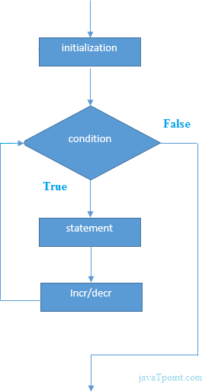

Example:
ForExample.java

//Java Program to demonstrate the example of for loop


Test it Now
Output:

1
2
3
4
5
6
7
8
9
10

Java Nested for Loop
If we have a for loop inside the another loop, it is known as nested for loop. The inner loop executes completely whenever outer loop executes.
Example: NestedForExample.java
public class NestedForExample { public static void main(String[] args) {
Output:

1 1
1 2
1 3
2 1
2 2
2 3
3 1
3 2
3 3
Pyramid Example 1: PyramidExample.java
public class PyramidExample {
public static void main(String[] args) {
Output:

*
* *
* * *
* * * *
* * * * *
Pyramid Example 2: PyramidExample2.java
public class PyramidExample2 { public static void main(String[] args) {
Output:

* * * * * *
* * * * *
* * * *
* * *
* *
*

Java for-each Loop
The for-each loop is used to traverse array or collection in Java. It is easier to use than simple for loop because we don't need to increment value and use subscript notation.
It works on the basis of elements and not the index. It returns element one by one in the defined variable.
Syntax:

for(data_type variable : array_name){
//code to be executed
Example:
ForEachExample.java

//Java For-each loop example which prints the


Test it Now
Output:

12
23
44
56
78

Java Labeled For Loop
We can have a name of each Java for loop. To do so, we use label before the for loop. It is useful while using the nested for loop as we can break/continue specific for loop.


Note: The break and continue keywords breaks or continues the innermost for loop respectively.

Syntax:

labelname:
for(initialization; condition; increment/
Example: LabeledForExample.java
//A Java program to demonstrate the use of labeled for loop
Output:

1 1
1 2
1 3
2 1
If you use break bb;, it will break inner loop only which is the default behaviour of any loop.
LabeledForExample2.java

public class LabeledForExample2 { public static void main(String[] args) {
Output:

1 1
1 2
1 3
2 1
3 1
3 2
3 3

Java Infinitive for Loop
If you use two semicolons ;; in the for loop, it will be infinitive for loop.
Syntax:

for(;;){
//code to be executed
Example:
ForExample.java

//Java program to demonstrate the use of infinite for loop
Output:

infinitive loop infinitive loop infinitive loop infinitive loop infinitive loop ctrl+c
Now, you need to press ctrl+c to exit from the program.
Java for Loop vs while Loop vs do-while Loop

Comparison | for loop | while loop | do-while loop
Introduction | The Java for loop is a control flow statement that iterates a part of the programs multiple times. | The Java while loop is a control flow statement that executes a part of the programs repeatedly on the basis of given boolean condition. | The Java do while loop is a control flow statement that executes a part of the programs at least once and the further execution depends upon the given boolean condition.
When to use | If the number of iteration is fixed, it is recommended to use for loop. | If the number of iteration is not fixed, it is recommended to use while loop. | If the number of iteration is not fixed and you must have to execute the loop at least once, it is recommended to use the do-while loop.
Syntax | for(init;condition;incr/ decr){  // code to be executed  } | while(condition){  //code to be executed  } | do{  //code to be executed  }while(condition);

Example | //for loop  for(int i=1;i<=10;i++){ System.out.println(i);  } | //while loop int i=1; while(i<=10){  System.out.println(i); i++;  } | //do-while loop int i=1;  do{ System.out.println(i); i++;  }while(i<=10);
Syntax for | for(;;){ | while(true){ | do{
infinitive | //code to be executed | //code to be | //code to be
loop | } | executed | executed
 |  | } | }while(true);

Java While Loop
The Java while loop is used to iterate a part of the program repeatedly until the specified Boolean condition is true. As soon as the Boolean condition becomes false, the loop automatically stops.
The while loop is considered as a repeating if statement. If the number of iteration is not fixed, it is recommended to use the while loop.
Syntax:

while (condition){
//code to be executed
The different parts of do-while loop:
- Condition: It is an expression which is tested. If the condition is true, the loop body is executed and control goes to update expression. When the condition becomes false, we exit the while loop.
Example:
i <=100
- Update expression: Every time the loop body is executed, this expression increments or decrements loop variable.
Example:
i++;
Flowchart of Java While Loop
Here, the important thing about while loop is that, sometimes it may not even execute. If the condition to be tested results into false, the loop body is skipped and first statement after the while loop will be executed.
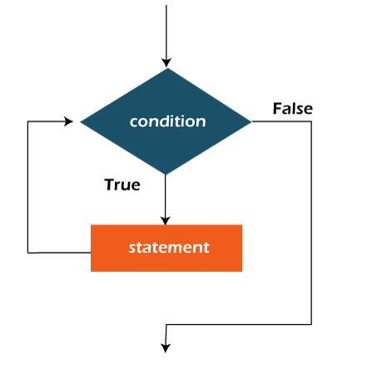

Example:
In the below example, we print integer values from 1 to 10. Unlike the for loop, we separately need to initialize and increment the variable used in the condition (here, i). Otherwise, the loop will execute infinitely.
WhileExample.java

public class WhileExample {
public static void main(String[] args) {


Test it Now
Output:

1
2
3
4
5
6
7
8
9
10

Java Infinitive While Loop
If you pass true in the while loop, it will be infinitive while loop.
Syntax:

while(true){
//code to be executed
Example:
WhileExample2.java

public class WhileExample2 {
public static void main(String[] args) {
Output:

infinitive while loop infinitive while loop infinitive while loop infinitive while loop infinitive while loop ctrl+c
In the above code, we need to enter Ctrl + C command to terminate the infinite loop.

Java do-while Loop
The Java do-while loop is used to iterate a part of the program repeatedly, until the specified condition is true. If the number of iteration is not fixed and you must have to execute the loop at least once, it is recommended to use a do-while loop.
Java do-while loop is called an exit control loop. Therefore, unlike while loop and for loop, the do-while check the condition at the end of loop body. The Java do- while loop is executed at least once because condition is checked after loop body.
Syntax:

do{
//code to be executed / loop body
The different parts of do-while loop:
- Condition: It is an expression which is tested. If the condition is true, the loop body is executed and control goes to update expression. As soon as the condition becomes false, loop breaks automatically.
Example:
i <=100
- Update expression: Every time the loop body is executed, the this expression increments or decrements loop variable.
Example: i++;

Note: The do block is executed at least once, even if the condition is false.

Flowchart of do-while loop:
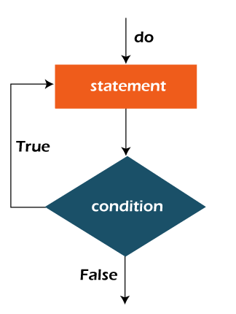

Example:
In the below example, we print integer values from 1 to 10. Unlike the for loop, we separately need to initialize and increment the variable used in the condition (here, i). Otherwise, the loop will execute infinitely.
DoWhileExample.java

public class DoWhileExample {
public static void main(String[] args) {


Test it Now
Output:

1
2
3
4
5
6
7
8
9
10

Java Infinitive do-while Loop
If you pass true in the do-while loop, it will be infinitive do-while loop.
Syntax:

do{
//code to be executed
Example:
DoWhileExample2.java

public class DoWhileExample2 { public static void main(String[] args) {
Output:

infinitive do while loop infinitive do while loop infinitive do while loop ctrl+c
In the above code, we need to enter Ctrl + C command to terminate the infinite loop.

Java Break Statement
When a break statement is encountered inside a loop, the loop is immediately terminated and the program control resumes at the next statement following the loop.
The Java break statement is used to break loop or switch statement. It breaks the current flow of the program at specified condition. In case of inner loop, it breaks only inner loop.
We can use Java break statement in all types of loops such as for loop, while loop and do-while loop.
Syntax:

jump-statement; break;
Flowchart of Break Statement
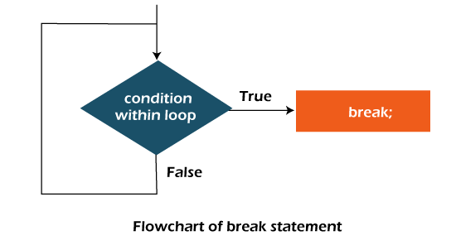

Java Break Statement with Loop
Example:
BreakExample.java

//Java Program to demonstrate the use of break statement
Output:

1
2
3
4

Java Break Statement with Inner Loop
It breaks inner loop only if you use break statement inside the inner loop.
Example:
BreakExample2.java

//Java Program to illustrate the use of break statement
Output:

1 1
1 2
1 3
2 1
3 1
3 2
3 3

Java Break Statement with Labeled For Loop
We can use break statement with a label. The feature is introduced since JDK 1.5. So, we can break any loop in Java now whether it is outer or inner loop.
Example:
BreakExample3.java

//Java Program to illustrate the use of continue statement
Output:

1 1
1 2
1 3
2 1

Java Break Statement in while loop
Example: BreakWhileExample.java
//Java Program to demonstrate the use of break statement
Output:

1
2
3
4

Java Break Statement in do-while loop
Example: BreakDoWhileExample.java
//Java Program to demonstrate the use of break statement
Output:

1
2
3
4

Java Break Statement with Switch
To understand the example of break with switch statement, please visit here: Java Switch Statement.

Java Continue Statement
The continue statement is used in loop control structure when you need to jump to the next iteration of the loop immediately. It can be used with for loop or while loop.
The Java continue statement is used to continue the loop. It continues the current flow of the program and skips the remaining code at the specified condition. In case of an inner loop, it continues the inner loop only.
We can use Java continue statement in all types of loops such as for loop, while loop and do-while loop.
Syntax:

jump-statement; continue;

Java Continue Statement Example
ContinueExample.java

//Java Program to demonstrate the use of continue statement


Test it Now
Output:

1
2
3
4
6
7
8
9
10
As you can see in the above output, 5 is not printed on the console. It is because the loop is continued when it reaches to 5.

Java Continue Statement with Inner Loop
It continues inner loop only if you use the continue statement inside the inner loop.
ContinueExample2.java

//Java Program to illustrate the use of continue statement
Output:

1 1
1 2
1 3
2 1
2 3
3 1
3 2
3 3

Java Continue Statement with Labelled For Loop
We can use continue statement with a label. This feature is introduced since JDK
1.5. So, we can continue any loop in Java now whether it is outer loop or inner.
Example: ContinueExample3.java
//Java Program to illustrate the use of continue statement
Output:

1 1
1 2
1 3
2 1
3 1
3 2
3 3

Java Continue Statement in while loop
ContinueWhileExample.java

//Java Program to demonstrate the use of continue statement


Test it Now
Output:

1
2
3
4
6
7
8
9
10

Java Continue Statement in do-while Loop
ContinueDoWhileExample.java

//Java Program to demonstrate the use of continue statement


Test it Now
Output:

4
6
7
8
9
10

Java Comments
The Java comments are the statements in a program that are not executed by the compiler and interpreter.

Why do we use comments in a code?

- Comments are used to make the program more readable by adding the details of the code.
- It makes easy to maintain the code and to find the errors easily.
- The comments can be used to provide information or explanation about the variable, method, class, or any statement.
- It can also be used to prevent the execution of program code while testing the alternative code.

Types of Java Comments
There are three types of comments in Java.
- Single Line Comment
- Multi Line Comment
- Documentation Comment
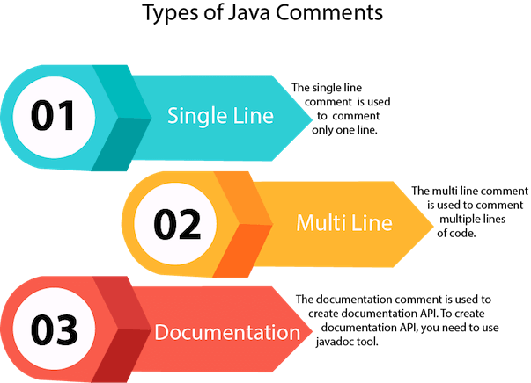

Java Single Line Comment

The single-line comment is used to comment only one line of the code. It is the widely used and easiest way of commenting the statements.
Single line comments starts with two forward slashes (//). Any text in front of // is not executed by Java.
Syntax:

//This is single line comment
Let's use single line comment in a Java program.
CommentExample1.java

public class CommentExample1 { public static void main(String[] args) {
Output:

10

Java Multi Line Comment

The multi-line comment is used to comment multiple lines of code. It can be used to explain a complex code snippet or to comment multiple lines of code at a time (as it will be difficult to use single-line comments there).
Multi-line comments are placed between /* and */. Any text between /* and */ is not executed by Java.
Syntax:

/* This
Let's use multi-line comment in a Java program.
CommentExample2.java

public class CommentExample2 { public static void main(String[] args) {
Output:


10

Note: Usually // is used for short comments and /* */ is used for longer comments.

Java Documentation Comment

Documentation comments are usually used to write large programs for a project or software application as it helps to create documentation API. These APIs are needed for reference, i.e., which classes, methods, arguments, etc., are used in the code.
To create documentation API, we need to use the javadoc tool. The documentation comments are placed between /** and */.
Syntax:

/**
*

javadoc tags
Some of the commonly used tags in documentation comments:

Tag | Syntax | Description
{@docRoot} | {@docRoot} | to depict relative path to root directory of generated document from any page.
@author | @author name - text | To add the author of the class.
@code | {@code text} | To show the text in code font without interpreting it as html markup or nested javadoc tag.
@version | @version version- text | To specify "Version" subheading and version-text when -version option is used.
@since | @since release | To add "Since" heading with since text to generated documentation.
@param | @param parameter- name description | To add a parameter with given name and description to 'Parameters' section.
@return | @return description | Required for every method that returns something (except void)
Let's use the Javadoc tag in a Java program.
Calculate.java

import java.io.*;

Compile it by javac tool:
Create Document
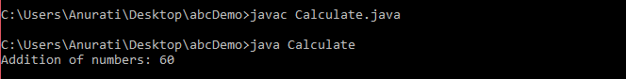
Create documentation API by javadoc tool:
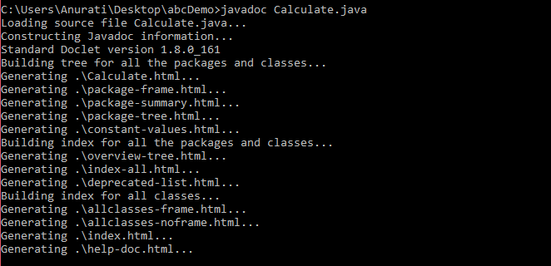
Now, the HTML files are created for the Calculate class in the current directory, i.e., abcDemo. Open the HTML files, and we can see the explanation of Calculate class provided through the documentation comment.

Are Java comments executable?
Ans: As we know, Java comments are not executed by the compiler or interpreter, however, before the lexical transformation of code in compiler, contents of the code are encoded into ASCII in order to make the processing easy.
Test.java

public class Test{
public static void main(String[] args)
Output:
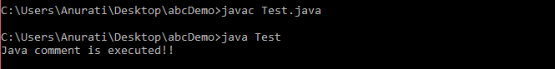

The above code generate the output because the compiler parses the Unicode character \u000d as a new line before the lexical transformation, and thus the code is transformed as shown below:
Test.java

public class Test{
public static void main(String[] args)
Thus, the Unicode character shifts the print statement to next line and it is executed as a normal Java code.

Java Programs | Java Programming Examples
Java programs are frequently asked in the interview. These programs can be asked from control statements, array, string, oops etc. Java basic programs like fibonacci series, prime numbers, factorial numbers and palindrome numbers are frequently asked in the interviews and exams. All these programs are given with the maximum examples and output. If you are new to Java programming, we will recommend you to read our Java tutorial first. Let's see the list of Java programs.
- Java Basic Programs
- Java Number Programs
- Java Array Programs
- Java Matrix Programs
- Java String Programs
- Java Searching and Sorting Programs
- Java Conversion Programs
- Pattern programs
- Singly Linked List Programs
- Circular Linked List Programs
- Doubly Linked List Programs
- Tree Programs

Java Basic Programs
- Fibonacci Series in Java
- Prime Number Program in Java
- Palindrome Program in Java
- Factorial Program in Java
- Armstrong Number in Java
- How to Generate Random Number in Java
- How to Print Pattern in Java
- How to Compare Two Objects in Java
- How to Create Object in Java
- How to Print ASCII Value in Java
Java Number Programs

- How to Reverse a Number in Java
- Java Program to convert Number to Word
- Automorphic Number Program in Java
- Peterson Number in Java
- Sunny Number in Java
- Tech Number in Java
- Fascinating Number in Java
- Keith Number in Java
- Neon Number in Java
- Spy Number in Java
- ATM program Java
- Autobiographical Number in Java
- Emirp Number in Java
- Sphenic Number in Java
- Buzz Number Java
- Duck Number Java
- Evil Number Java
- ISBN Number Java
- Krishnamurthy Number Java
- Bouncy Number in Java
- Mystery Number in Java
- Smith Number in Java
- Strontio Number in Java
- Xylem and Phloem Number in Java
- nth Prime Number Java
- Java Program to Display Alternate Prime Numbers
- Java Program to Find Square Root of a Number Without sqrt Method
- Java Program to Swap Two Numbers Using Bitwise Operator
- Java Program to Find GCD of Two Numbers
- Java Program to Find Largest of Three Numbers
- Java Program to Find Smallest of Three Numbers Using Ternary Operator
- Java Program to Check if a Number is Positive or Negative
- Java Program to Check if a Given Number is Perfect Square
- Java Program to Display Even Numbers From 1 to 100
- Java Program to Display Odd Numbers From 1 to 100
- Java Program to Find Sum of Natural Numbers
Java Array Programs

- Java Program to copy all elements of one array into another array
- Java Program to find the frequency of each element in the array
- Java Program to left rotate the elements of an array
- Java Program to print the duplicate elements of an array
- Java Program to print the elements of an array
- Java Program to print the elements of an array in reverse order
- Java Program to print the elements of an array present on even position
- Java Program to print the elements of an array present on odd position
- Java Program to print the largest element in an array
- Java Program to print the smallest element in an array
- Java Program to print the number of elements present in an array
- Java Program to print the sum of all the items of the array
- Java Program to right rotate the elements of an array
- Java Program to sort the elements of an array in ascending order
- Java Program to sort the elements of an array in descending order
- Java Program to Find 3rd Largest Number in an array
- Java Program to Find 2nd Largest Number in an array
- Java Program to Find Largest Number in an array
- Java to Program Find 2nd Smallest Number in an array
- Java Program to Find Smallest Number in an array
- Java Program to Remove Duplicate Element in an array
- Java Program to Print Odd and Even Numbers from an array
- How to Sort an Array in Java

Java Matrix Programs

- Java Matrix Programs
- Java Program to Add Two Matrices
- Java Program to Multiply Two Matrices
- Java Program to subtract the two matrices
- Java Program to determine whether two matrices are equal
- Java Program to display the lower triangular matrix
- Java Program to display the upper triangular matrix
- Java Program to find the frequency of odd & even numbers in the given matrix
- Java Program to find the product of two matrices
- Java Program to find the sum of each row and each column of a matrix
- Java Program to find the transpose of a given matrix
- Java Program to determine whether a given matrix is an identity matrix
- Java Program to determine whether a given matrix is a sparse matrix
- Java Program to Transpose matrix

Java String Programs

- Java Program to count the total number of characters in a string
- Java Program to count the total number of characters in a string 2
- Java Program to count the total number of punctuation characters exists in a String
- Java Program to count the total number of vowels and consonants in a string
- Java Program to determine whether two strings are the anagram
- Java Program to divide a string in 'N' equal parts.
- Java Program to find all subsets of a string
- Java Program to find the longest repeating sequence in a string
- Java Program to find all the permutations of a string
- Java Program to remove all the white spaces from a string
- Java Program to replace lower-case characters with upper-case and vice-versa
- Java Program to replace the spaces of a string with a specific character
- Java Program to determine whether a given string is palindrome
- Java Program to determine whether one string is a rotation of another
- Java Program to find maximum and minimum occurring character in a string
- Java Program to find Reverse of the string
- Java program to find the duplicate characters in a string
- Java program to find the duplicate words in a string
- Java Program to find the frequency of characters
- Java Program to find the largest and smallest word in a string
- Java Program to find the most repeated word in a text file
- Java Program to find the number of the words in the given text file
- Java Program to separate the Individual Characters from a String
- Java Program to swap two string variables without using third or temp variable.
- Java Program to print smallest and biggest possible palindrome word in a given string
- Reverse String in Java Word by Word
- Reserve String without reverse() function
Java Searching and Sorting Programs

- Linear Search in Java
- Binary Search in Java
- Bubble Sort in Java
- Selection Sort in Java
- Insertion Sort in Java

Java Conversion Programs

- How to convert String to int in Java
- How to convert int to String in Java
- How to convert String to long in Java
- How to convert long to String in Java
- How to convert String to float in Java
- How to convert float to String in Java
- How to convert String to double in Java
- How to convert double to String in Java
- How to convert String to Date in Java
- How to convert Date to String in Java
- How to convert String to char in Java
- How to convert char to String in Java
- How to convert String to Object in Java
- How to convert Object to String in Java
- How to convert int to long in Java
- How to convert long to int in Java
- How to convert int to double in Java
- How to convert double to int in Java
- How to convert char to int in Java
- How to convert int to char in Java
- How to convert String to boolean in Java
- How to convert boolean to String in Java
- How to convert Date to Timestamp in Java
- How to convert Timestamp to Date in Java
- How to convert Binary to Decimal in Java
- How to convert Decimal to Binary in Java
- How to convert Hex to Decimal in Java
- How to convert Decimal to Hex in Java
- How to convert Octal to Decimal in Java
- How to convert Decimal to Octal in Java

Java Pattern programs

- Java program to print the following spiral pattern on the console
- Java program to print the following pattern
- Java program to print the following pattern 2
- Java program to print the following pattern 3
- Java program to print the following pattern 4
- Java program to print the following pattern 5
- Java program to print the following pattern on the console
- Java program to print the following pattern on the console 2
- Java program to print the following pattern on the console 3
- Java program to print the following pattern on the console 4
- Java program to print the following pattern on the console 5
- Java program to print the following pattern on the console 6
- Java program to print the following pattern on the console 7
- Java program to print the following pattern on the console 8
- Java program to print the following pattern on the console 9
- Java program to print the following pattern on the console 10
- Java program to print the following pattern on the console 11
- Java program to print the following pattern on the console 12

Java Singly Linked List Programs

- Singly linked list Examples in Java
- Java Program to create and display a singly linked list
- Java program to create a singly linked list of n nodes and count the number of nodes
- Java program to create a singly linked list of n nodes and display it in reverse order
- Java program to delete a node from the beginning of the singly linked list
- Java program to delete a node from the middle of the singly linked list
- Java program to delete a node from the end of the singly linked list
- Java program to determine whether a singly linked list is the palindrome
- Java program to find the maximum and minimum value node from a linked list
- Java Program to insert a new node at the middle of the singly linked list
- Java program to insert a new node at the beginning of the singly linked list
- Java program to insert a new node at the end of the singly linked list
- Java program to remove duplicate elements from a singly linked list
- Java Program to search an element in a singly linked list

Java Circular Linked List Programs

- Java program to create and display a Circular Linked List
- Java program to create a Circular Linked List of N nodes and count the number of nodes
- Java program to create a Circular Linked List of n nodes and display it in reverse order
- Java program to delete a node from the beginning of the Circular Linked List
- Java program to delete a node from the end of the Circular Linked List
- Java program to delete a node from the middle of the Circular Linked List
- Java program to find the maximum and minimum value node from a circular linked list
- Java program to insert a new node at the beginning of the Circular Linked List
- Java program to insert a new node at the end of the Circular Linked List
- Java program to insert a new node at the middle of the Circular Linked List
- Java program to remove duplicate elements from a Circular Linked List
- Java program to search an element in a Circular Linked List
- Java program to sort the elements of the Circular Linked List

Java Doubly Linked List Programs

- Java program to convert a given binary tree to doubly linked list
- Java program to create a doubly linked list from a ternary tree
- Java program to create a doubly linked list of n nodes and count the number of nodes
- Java program to create a doubly linked list of n nodes and display it in reverse order
- Java program to create and display a doubly linked list
- Java program to delete a new node from the beginning of the doubly linked list
- Java program to delete a new node from the end of the doubly linked list
- Java program to delete a new node from the middle of the doubly linked list
- Java program to find the maximum and minimum value node from a doubly linked list
- Java program to insert a new node at the beginning of the Doubly Linked list
10) Java program to insert a new node at the end of the Doubly Linked List
- Java program to insert a new node at the middle of the Doubly Linked List
- Java program to remove duplicate elements from a Doubly Linked List
- Java program to rotate doubly linked list by N nodes
- Java program to search an element in a doubly linked list
- Java program to sort the elements of the doubly linked list

Java OOPs Concepts
In this page, we will learn about the basics of OOPs. Object-Oriented Programming is a paradigm that provides many concepts, such as inheritance, data binding, polymorphism, etc.
Simula is considered the first object-oriented programming language. The programming paradigm where everything is represented as an object is known as a truly object-oriented programming language.
Smalltalk is considered the first truly object-oriented programming language. The popular object-oriented languages are Java, C#, PHP, Python, C++, etc.
The main aim of object-oriented programming is to implement real-world entities, for example, object, classes, abstraction, inheritance, polymorphism, etc.

OOPs (Object-Oriented Programming System)
Object means a real-world entity such as a pen, chair, table, computer, watch, etc. Object-Oriented Programming is a methodology or paradigm to design a program using classes and objects. It simplifies software development and maintenance by providing some concepts:
- Object
- Class
- Inheritance
- Polymorphism
- Abstraction
- Encapsulation
Apart from these concepts, there are some other terms which are used in Object- Oriented design:
- Coupling
- Cohesion
- Association
- Aggregation
- Composition
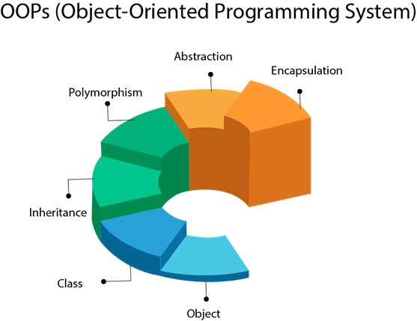

Object
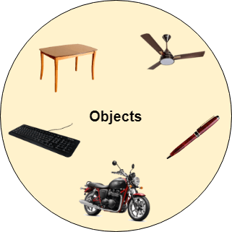
Any entity that has state and behavior is known as an object. For example, a chair, pen, table, keyboard, bike, etc. It can be physical or logical.
An Object can be defined as an instance of a class. An object contains an address and takes up some space in memory. Objects can communicate without knowing the details of each other's data or code. The only necessary thing is the type of message accepted and the type of response returned by the objects.
Example: A dog is an object because it has states like color, name, breed, etc. as well as behaviors like wagging the tail, barking, eating, etc.

Class
Collection of objects is called class. It is a logical entity.
A class can also be defined as a blueprint from which you can create an individual object. Class doesn't consume any space.

Inheritance

When one object acquires all the properties and behaviors of a parent object, it is known as inheritance. It provides code reusability. It is used to achieve runtime polymorphism.
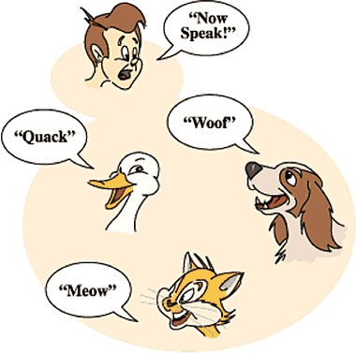

Polymorphism

If one task is performed in different ways, it is known as polymorphism. For example: to convince the customer differently, to draw something, for example, shape, triangle, rectangle, etc.
In Java, we use method overloading and method overriding to achieve polymorphism.
Another example can be to speak something; for example, a cat speaks meow, dog barks woof, etc.

Abstraction

Hiding internal details and showing functionality is known as abstraction. For example phone call, we don't know the internal processing.
In Java, we use abstract class and interface to achieve abstraction.


Encapsulation

Binding (or wrapping) code and data together into a single unit are known as encapsulation. For example, a capsule, it is wrapped with different medicines.
A java class is the example of encapsulation. Java bean is the fully encapsulated class because all the data members are private here.

Coupling

Coupling refers to the knowledge or information or dependency of another class. It arises when classes are aware of each other. If a class has the details information of another class, there is strong coupling. In Java, we use private, protected, and public modifiers to display the visibility level of a class, method, and field. You can use interfaces for the weaker coupling because there is no concrete implementation.

Cohesion

Cohesion refers to the level of a component which performs a single well-defined task. A single well-defined task is done by a highly cohesive method. The weakly cohesive method will split the task into separate parts. The java.io package is a highly cohesive package because it has I/O related classes and interface. However, the java.util package is a weakly cohesive package because it has unrelated classes and interfaces.

Association

Association represents the relationship between the objects. Here, one object can be associated with one object or many objects. There can be four types of association between the objects:
- One to One
- One to Many
- Many to One, and
- Many to Many
Let's understand the relationship with real-time examples. For example, One country can have one prime minister (one to one), and a prime minister can have many ministers (one to many). Also, many MP's can have one prime minister (many to one), and many ministers can have many departments (many to many).
Association can be undirectional or bidirectional.

Aggregation

Aggregation is a way to achieve Association. Aggregation represents the relationship where one object contains other objects as a part of its state. It represents the weak relationship between objects. It is also termed as a has-a relationship in Java. Like, inheritance represents the is-a relationship. It is another way to reuse objects.

Composition

The composition is also a way to achieve Association. The composition represents the relationship where one object contains other objects as a part of its state.
There is a strong relationship between the containing object and the dependent object. It is the state where containing objects do not have an independent existence. If you delete the parent object, all the child objects will be deleted automatically.

Advantage of OOPs over Procedure-oriented programming language
- OOPs makes development and maintenance easier, whereas, in a procedure- oriented programming language, it is not easy to manage if code grows as project size increases.
- OOPs provides data hiding, whereas, in a procedure-oriented programming language, global data can be accessed from anywhere.
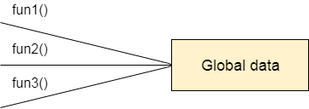
Figure: Data Representation in Procedure-Oriented Programming

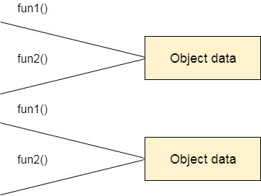
Figure: Data Representation in Object-Oriented Programming
- OOPs provides the ability to simulate real-world event much more effectively. We can provide the solution of real word problem if we are using the Object- Oriented Programming language.

Java Naming Convention
Java naming convention is a rule to follow as you decide what to name your identifiers such as class, package, variable, constant, method, etc.
But, it is not forced to follow. So, it is known as convention not rule. These conventions are suggested by several Java communities such as Sun Microsystems and Netscape.
All the classes, interfaces, packages, methods and fields of Java programming language are given according to the Java naming convention. If you fail to follow these conventions, it may generate confusion or erroneous code.

Advantage of Naming Conventions in Java
By using standard Java naming conventions, you make your code easier to read for yourself and other programmers. Readability of Java program is very important. It indicates that less time is spent to figure out what the code does.

Naming Conventions of the Different Identifiers
The following table shows the popular conventions used for the different identifiers.

Identifiers Type | Naming Rules | Examples
Class | It should start with the uppercase letter.  It should be a noun such as Color, Button, System, Thread, etc.  Use appropriate words, instead of acronyms. | public class Employee  {  //code snippet  }
Interface | It should start with the uppercase letter.  It should be an adjective such as Runnable, Remote, ActionListener. Use appropriate words, instead of acronyms. | interface Printable  {  //code snippet  }

Method | It should start with lowercase letter. It should be a verb such as main(), print(), println().  If the name contains multiple words, start it with a lowercase letter followed by an uppercase letter such as actionPerformed(). | class Employee  {  // method void draw()  {  //code snippet  }  }
Variable | It should start with a lowercase letter such as id, name.  It should not start with the special characters like & (ampersand), $ (dollar), _ (underscore).  If the name contains multiple words, start it with the lowercase letter followed by an uppercase letter such as firstName, lastName.  Avoid using one-character variables such as x, y, z. | class Employee  {  // variable int id;  //code snippet  }
Package | It should be a lowercase letter such as java, lang.  If the name contains multiple words, it should be separated by dots (.) such as java.util, java.lang. | //package  package com.javatpoint;  class Employee  {  //code snippet  }
Constant | It should be in uppercase letters such as RED, YELLOW.  If the name contains multiple words, it should be separated by an underscore(_) such as MAX_PRIORITY. It may contain digits but not as the first letter. | class Employee  {  //constant  static final int MIN_AGE  = 18;  //code snippet  }

CamelCase in Java naming conventions
Java follows camel-case syntax for naming the class, interface, method, and variable.
If the name is combined with two words, the second word will start with uppercase letter always such as actionPerformed(), firstName, ActionEvent, ActionListener, etc.

Objects and Classes in Java
In this page, we will learn about Java objects and classes. In object-oriented programming technique, we design a program using objects and classes.
An object in Java is the physical as well as a logical entity, whereas, a class in Java is a logical entity only.

What is an object in Java

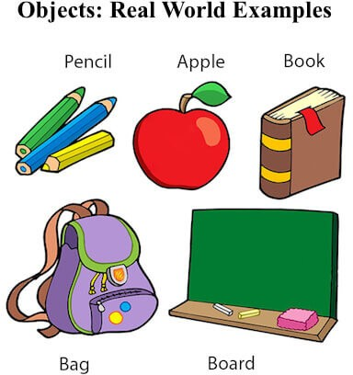
An entity that has state and behavior is known as an object e.g., chair, bike, marker, pen, table, car, etc. It can be physical or logical (tangible and intangible). The example of an intangible object is the banking system.
An object has three characteristics:
- State: represents the data (value) of an object.
- Behavior: represents the behavior (functionality) of an object such as
deposit, withdraw, etc.
- Identity: An object identity is typically implemented via a unique ID. The value of the ID is not visible to the external user. However, it is used internally by the JVM to identify each object uniquely.
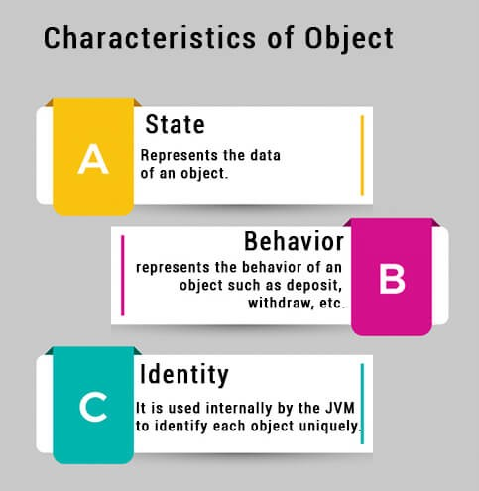
For Example, Pen is an object. Its name is Reynolds; color is white, known as its state. It is used to write, so writing is its behavior.
An object is an instance of a class. A class is a template or blueprint from which objects are created. So, an object is the instance(result) of a class.
Object Definitions:

- An object is a real-world entity.
- An object is a runtime entity.
- The object is an entity which has state and behavior.
- The object is an instance of a class.

What is a class in Java
A class is a group of objects which have common properties. It is a template or blueprint from which objects are created. It is a logical entity. It can't be physical.
A class in Java can contain:
- Fields
- Methods
- Constructors
- Blocks
- Nested class and interface

Class in Java
Syntax to declare a class:

class <class_name>{ field;

Instance variable in Java

A variable which is created inside the class but outside the method is known as an instance variable. Instance variable doesn't get memory at compile time. It gets memory at runtime when an object or instance is created. That is why it is known as an instance variable.

Method in Java

In Java, a method is like a function which is used to expose the behavior of an object.

Advantage of Method

- Code Reusability
- Code Optimization

new keyword in Java

The new keyword is used to allocate memory at runtime. All objects get memory in Heap memory area.

Object and Class Example: main within the class
In this example, we have created a Student class which has two data members id and name. We are creating the object of the Student class by new keyword and printing the object's value.
Here, we are creating a main() method inside the class.
File: Student.java

//Java Program to illustrate how to define a class and fields


Test it Now
Output:
0
null

Object and Class Example: main outside the class
In real time development, we create classes and use it from another class. It is a better approach than previous one. Let's see a simple example, where we are having main() method in another class.
We can have multiple classes in different Java files or single Java file. If you define multiple classes in a single Java source file, it is a good idea to save the file name with the class name which has main() method.
File: TestStudent1.java

//Java Program to demonstrate having the main method in


Test it Now
Output:
0
null

3 Ways to initialize object
There are 3 ways to initialize object in Java.
- By reference variable
- By method
- By constructor

Object and Class Example: Initialization through reference
Initializing an object means storing data into the object. Let's see a simple example where we are going to initialize the object through a reference variable.
File: TestStudent2.java

class Student{ int id;


Test it Now
Output:
101 Sonoo
We can also create multiple objects and store information in it through reference variable.
File: TestStudent3.java

class Student{ int id;


Test it Now
Output:
- Sonoo
- Amit

Object and Class Example: Initialization through method
In this example, we are creating the two objects of Student class and initializing the value to these objects by invoking the insertRecord method. Here, we are displaying the state (data) of the objects by invoking the displayInformation() method.
File: TestStudent4.java

class Student{ int rollno;


Test it Now
Output:
111 Karan
222 Aryan
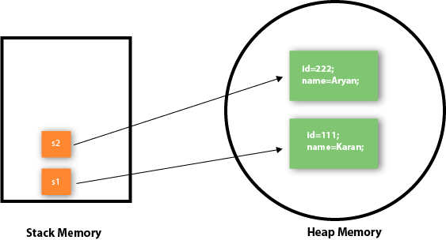
As you can see in the above figure, object gets the memory in heap memory area. The reference variable refers to the object allocated in the heap memory area.
Here, s1 and s2 both are reference variables that refer to the objects allocated in memory.

Object and Class Example: Initialization through a constructor
We will learn about constructors in Java later.

Method in Java
In general, a method is a way to perform some task. Similarly, the method in Java is a collection of instructions that performs a specific task. It provides the reusability of code. We can also easily modify code using methods. In this section, we will learn what is a method in Java, types of methods, method declaration, and how to call a method in Java.

What is a method in Java?
A method is a block of code or collection of statements or a set of code grouped together to perform a certain task or operation. It is used to achieve the reusability of code. We write a method once and use it many times. We do not require to write code again and again. It also provides the easy modification and readability of code, just by adding or removing a chunk of code. The method is executed only when we call or invoke it.
The most important method in Java is the main() method. If you want to read more about the main() method, go through the link https://www.javatpoint.com/ java-main-method.

Method Declaration

The method declaration provides information about method attributes, such as visibility, return-type, name, and arguments. It has six components that are known as method header, as we have shown in the following figure.
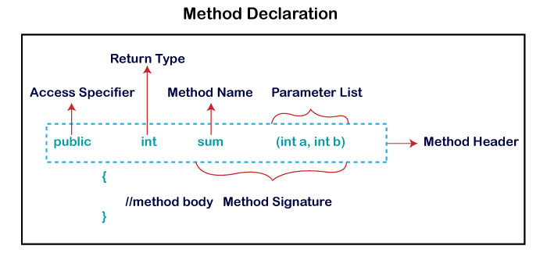
Method Signature: Every method has a method signature. It is a part of the method declaration. It includes the method name and parameter list.
Access Specifier: Access specifier or modifier is the access type of the method. It specifies the visibility of the method. Java provides four types of access specifier:
- Public: The method is accessible by all classes when we use public specifier in our application.
- Private: When we use a private access specifier, the method is accessible only in the classes in which it is defined.
- Protected: When we use protected access specifier, the method is accessible within the same package or subclasses in a different package.
- Default: When we do not use any access specifier in the method declaration, Java uses default access specifier by default. It is visible only from the same package only.
Return Type: Return type is a data type that the method returns. It may have a primitive data type, object, collection, void, etc. If the method does not return anything, we use void keyword.
Method Name: It is a unique name that is used to define the name of a method. It must be corresponding to the functionality of the method. Suppose, if we are creating a method for subtraction of two numbers, the method name must be subtraction(). A method is invoked by its name.
Parameter List: It is the list of parameters separated by a comma and enclosed in the pair of parentheses. It contains the data type and variable name. If the method has no parameter, left the parentheses blank.
Method Body: It is a part of the method declaration. It contains all the actions to be performed. It is enclosed within the pair of curly braces.

Naming a Method
While defining a method, remember that the method name must be a verb and start with a lowercase letter. If the method name has more than two words, the first name must be a verb followed by adjective or noun. In the multi-word method name, the first letter of each word must be in uppercase except the first word. For example:
Single-word method name: sum(), area()
Multi-word method name: areaOfCircle(), stringComparision()
It is also possible that a method has the same name as another method name in the same class, it is known as method overloading.

Types of Method
There are two types of methods in Java:
- Predefined Method
- User-defined Method

Predefined Method

In Java, predefined methods are the method that is already defined in the Java class libraries is known as predefined methods. It is also known as the standard library method or built-in method. We can directly use these methods just by calling them in the program at any point. Some pre-defined methods are length(), equals(), compareTo(), sqrt(), etc. When we call any of the predefined methods in our program, a series of codes related to the corresponding method runs in the background that is already stored in the library.
Each and every predefined method is defined inside a class. Such as print() method is defined in the java.io.PrintStream class. It prints the statement that we write inside the method. For example, print("Java"), it prints Java on the console.
Let's see an example of the predefined method.
Demo.java

public class Demo
{
Output:

The maximum number is: 9
In the above example, we have used three predefined methods main(), print(), and max(). We have used these methods directly without declaration because they are predefined. The print() method is a method of PrintStream class that prints the result on the console. The max() method is a method of the Math class that returns the greater of two numbers.
We can also see the method signature of any predefined method by using the link https://docs.oracle.com/. When we go through the link and see the max() method signature, we find the following:
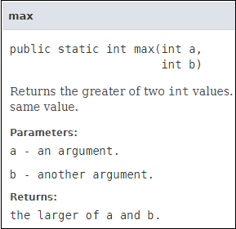
In the above method signature, we see that the method signature has access specifier public, non-access modifier static, return type int, method name max(), parameter list (int a, int b). In the above example, instead of defining the method, we have just invoked the method. This is the advantage of a predefined method. It makes programming less complicated.
Similarly, we can also see the method signature of the print() method.

User-defined Method

The method written by the user or programmer is known as a user-defined
method. These methods are modified according to the requirement.
How to Create a User-defined Method

Let's create a user defined method that checks the number is even or odd. First, we will define the method.

//user defined method
public static void findEvenOdd(int num)
We have defined the above method named findevenodd(). It has a parameter num
of type int. The method does not return any value that's why we have used void. The method body contains the steps to check the number is even or odd. If the number is even, it prints the number is even, else prints the number is odd.
How to Call or Invoke a User-defined Method

Once we have defined a method, it should be called. The calling of a method in a program is simple. When we call or invoke a user-defined method, the program control transfer to the called method.

import java.util.Scanner; public class EvenOdd
In the above code snippet, as soon as the compiler reaches at line findEvenOdd(num), the control transfer to the method and gives the output accordingly.
Let's combine both snippets of codes in a single program and execute it.
EvenOdd.java

import java.util.Scanner; public class EvenOdd
Output 1:

Enter the number: 12
12 is even
Output 2:

Enter the number: 99
99 is odd
Let's see another program that return a value to the calling method.
In the following program, we have defined a method named add() that sum up the two numbers. It has two parameters n1 and n2 of integer type. The values of n1 and n2 correspond to the value of a and b, respectively. Therefore, the method adds the value of a and b and store it in the variable s and returns the sum.
Addition.java

public class Addition
{
Output:

The sum of a and b is= 24

Static Method

A method that has static keyword is known as static method. In other words, a method that belongs to a class rather than an instance of a class is known as a static method. We can also create a static method by using the keyword static before the method name.
The main advantage of a static method is that we can call it without creating an object. It can access static data members and also change the value of it. It is used to create an instance method. It is invoked by using the class name. The best example of a static method is the main() method.
Example of static method

Display.java

public class Display
{
Output:

It is an example of a static method.

Instance Method

The method of the class is known as an instance method. It is a non-static method defined in the class. Before calling or invoking the instance method, it is necessary to create an object of its class. Let's see an example of an instance method.
InstanceMethodExample.java

public class InstanceMethodExample
{
Output:

The sum is: 25
There are two types of instance method:
- Accessor Method
- Mutator Method

Accessor Method: The method(s) that reads the instance variable(s) is known as the accessor method. We can easily identify it because the method is prefixed with the word get. It is also known as getters. It returns the value of the private field. It is used to get the value of the private field.
Example

public int getId()
{

Mutator Method: The method(s) read the instance variable(s) and also modify the values. We can easily identify it because the method is prefixed with the word set. It is also known as setters or modifiers. It does not return anything. It accepts a parameter of the same data type that depends on the field. It is used to set the value of the private field.
Example

public void setRoll(int roll)
{
Example of accessor and mutator method

Student.java

public class Student
{

Abstract Method

The method that does not has method body is known as abstract method. In other words, without an implementation is known as abstract method. It always declares in the abstract class. It means the class itself must be abstract if it has abstract method. To create an abstract method, we use the keyword abstract.
Syntax

abstract void method_name();
Example of abstract method

Demo.java

abstract class Demo //abstract class
{
Output:

Abstract method...

Factory method

It is a method that returns an object to the class to which it belongs. All static methods are factory methods. For example, NumberFormat obj = NumberFormat.getNumberInstance();

Constructors in Java
In Java, a constructor is a block of codes similar to the method. It is called when an instance of the class is created. At the time of calling constructor, memory for the object is allocated in the memory.
It is a special type of method which is used to initialize the object.
Every time an object is created using the new() keyword, at least one constructor is called.
It calls a default constructor if there is no constructor available in the class. In such case, Java compiler provides a default constructor by default.
There are two types of constructors in Java: no-arg constructor, and parameterized constructor.
Note: It is called constructor because it constructs the values at the time of object creation. It is not necessary to write a constructor for a class. It is because java compiler creates a default constructor if your class doesn't have any.

Rules for creating Java constructor

There are two rules defined for the constructor.
  - Constructor name must be the same as its class name
  - A Constructor must have no explicit return type
  - A Java constructor cannot be abstract, static, final, and synchronized


Note: We can use access modifiers while declaring a constructor. It controls the object creation. In other words, we can have private, protected, public or default constructor in Java.

Types of Java constructors
There are two types of constructors in Java:
- Default constructor (no-arg constructor)
- Parameterized constructor
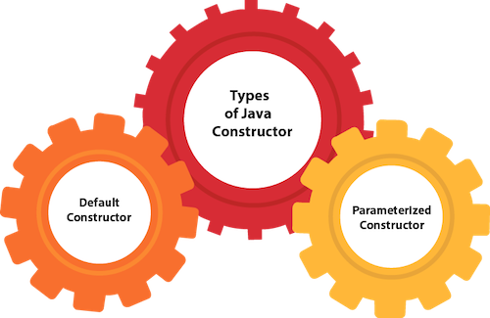

Java Default Constructor
A constructor is called "Default Constructor" when it doesn't have any parameter.
Syntax of default constructor:

<class_name>(){}

Example of default constructor
In this example, we are creating the no-arg constructor in the Bike class. It will be invoked at the time of object creation.

//Java Program to create and call a default constructor


Test it Now
Output:

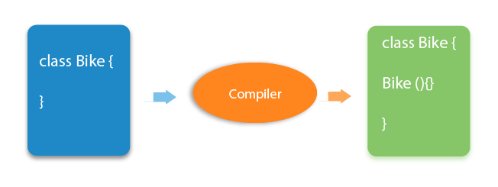
Bike is created

Rule: If there is no constructor in a class, compiler automatically creates a default constructor.

Q) What is the purpose of a default constructor?

The default constructor is used to provide the default values to the object like 0, null, etc., depending on the type.

Example of default constructor that displays the default values

//Let us see another example of default constructor


Test it Now
Output:
0 null
0 null
Explanation:In the above class,you are not creating any constructor so compiler provides you a default constructor. Here 0 and null values are provided by default constructor.

Java Parameterized Constructor

A constructor which has a specific number of parameters is called a parameterized constructor.
Why use the parameterized constructor?

The parameterized constructor is used to provide different values to distinct objects. However, you can provide the same values also.

Example of parameterized constructor
In this example, we have created the constructor of Student class that have two parameters. We can have any number of parameters in the constructor.

//Java Program to demonstrate the use of the parameterized constructor.


Test it Now
Output:
111 Karan
222 Aryan

Constructor Overloading in Java
In Java, a constructor is just like a method but without return type. It can also be overloaded like Java methods.
Constructor overloading in Java is a technique of having more than one constructor with different parameter lists. They are arranged in a way that each constructor performs a different task. They are differentiated by the compiler by the number of parameters in the list and their types.

Example of Constructor Overloading

//Java program to overload constructors class Student5{


Test it Now
Output:
111 Karan 0
222 Aryan 25

Difference between constructor and method in Java
There are many differences between constructors and methods. They are given below.

Java Constructor | Java Method
A constructor is used to initialize the state of an object. | A method is used to expose the behavior of an object.
A constructor must not have a return type. | A method must have a return type.
The constructor is invoked implicitly. | The method is invoked explicitly.
The Java compiler provides a default constructor if you don't have any constructor in a class. | The method is not provided by the compiler in any case.
The constructor name must be same as the class name. | The method name may or may not be same as the class name.

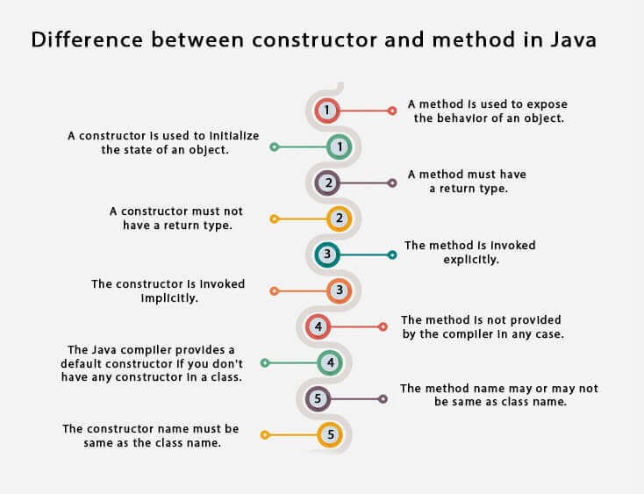

Java Copy Constructor
There is no copy constructor in Java. However, we can copy the values from one object to another like copy constructor in C++.
There are many ways to copy the values of one object into another in Java. They are:
- By constructor
- By assigning the values of one object into another
- By clone() method of Object class
In this example, we are going to copy the values of one object into another using Java constructor.

//Java program to initialize the values from one object to another object.


Test it Now
Output:
111 Karan
111 Karan

Copying values without constructor
We can copy the values of one object into another by assigning the objects values to another object. In this case, there is no need to create the constructor.

class Student7{ int id;


Test it Now
Output:
111 Karan
111 Karan

Does constructor return any value?

Yes, it is the current class instance (You cannot use return type yet it returns a value).

Can constructor perform other tasks instead of initialization?

Yes, like object creation, starting a thread, calling a method, etc. You can perform any operation in the constructor as you perform in the method.

Is there Constructor class in Java?

Yes.

Java static keyword
The static keyword in Java is used for memory management mainly. We can apply static keyword with variables, methods, blocks and nested classes. The static keyword belongs to the class than an instance of the class.
The static can be:
  - Variable (also known as a class variable)
  - Method (also known as a class method)
  - Block
  - Nested class
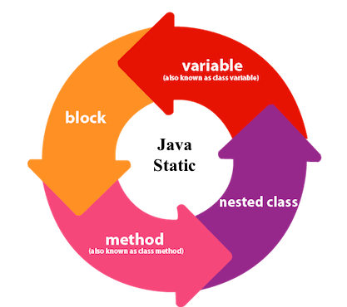

Java static variable
If you declare any variable as static, it is known as a static variable.
  - The static variable can be used to refer to the common property of all objects (which is not unique for each object), for example, the company name of employees, college name of students, etc.
  - The static variable gets memory only once in the class area at the time of class loading.
Advantages of static variable

It makes your program memory efficient (i.e., it saves memory).
Understanding the problem without static variable

class Student{ int rollno;
Suppose there are 500 students in my college, now all instance data members will get memory each time when the object is created. All students have its unique rollno and name, so instance data member is good in such case. Here, "college" refers to the common property of all objects. If we make it static, this field will get the memory only once.

Java static property is shared to all objects.

Example of static variable

//Java Program to demonstrate the use of static variable


Test it Now
Output:
111 Karan ITS
222 Aryan ITS
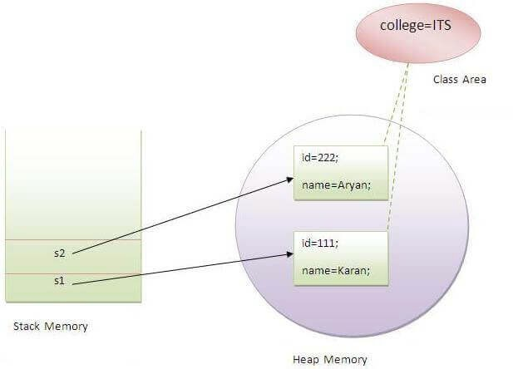

Program of the counter without static variable
In this example, we have created an instance variable named count which is incremented in the constructor. Since instance variable gets the memory at the time of object creation, each object will have the copy of the instance variable. If it is incremented, it won't reflect other objects. So each object will have the value 1 in the count variable.

//Java Program to demonstrate the use of an instance variable


Test it Now
Output:
1
1
1

Program of counter by static variable
As we have mentioned above, static variable will get the memory only once, if any object changes the value of the static variable, it will retain its value.

//Java Program to illustrate the use of static variable which


Test it Now
Output:
1
2
3

Java static method
If you apply static keyword with any method, it is known as static method.
  - A static method belongs to the class rather than the object of a class.
  - A static method can be invoked without the need for creating an instance of a class.
  - A static method can access static data member and can change the value of it.

Example of static method

//Java Program to demonstrate the use of a static method.


Test it Now

Output:111 Karan BBDIT
222 Aryan BBDIT
333 Sonoo BBDIT

Another example of a static method that performs a normal calculation

//Java Program to get the cube of a given number using the static method


Test it Now

Output:125
Restrictions for the static method

There are two main restrictions for the static method. They are:
- The static method can not use non static data member or call non-static method directly.
- this and super cannot be used in static context.

class A{
int a=40;//non static


Test it Now
Output:Compile Time Error

Q) Why is the Java main method static?

Ans) It is because the object is not required to call a static method. If it were a non- static method, JVM creates an object first then call main() method that will lead the problem of extra memory allocation.

Java static block

  - Is used to initialize the static data member.
  - It is executed before the main method at the time of classloading.

Example of static block

class A2{ static{System.out.println("static block is


Test it Now

Output:static block is invoked Hello main

this keyword in Java
There can be a lot of usage of Java this keyword. In Java, this is a reference variable that refers to the current object.
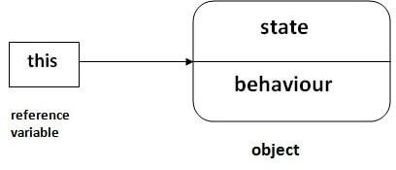

Usage of Java this keyword
Here is given the 6 usage of java this keyword.
- this can be used to refer current class instance variable.
- this can be used to invoke current class method (implicitly)
- this() can be used to invoke current class constructor.
- this can be passed as an argument in the method call.
- this can be passed as argument in the constructor call.
- this can be used to return the current class instance from the method.
Suggestion: If you are beginner to java, lookup only three usages of this keyword.
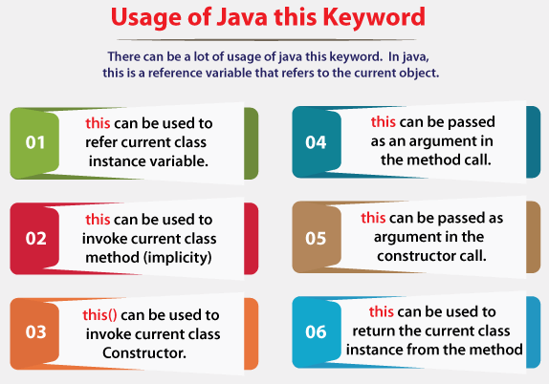

this: to refer current class instance variable

The this keyword can be used to refer current class instance variable. If there is ambiguity between the instance variables and parameters, this keyword resolves the problem of ambiguity.
Understanding the problem without this keyword

Let's understand the problem if we don't use this keyword by the example given below:

class Student{ int rollno;


Test it Now
Output:

0 null 0.0
0 null 0.0
In the above example, parameters (formal arguments) and instance variables are same. So, we are using this keyword to distinguish local variable and instance variable.
Solution of the above problem by this keyword

class Student{ int rollno;


Test it Now
Output:

111 ankit 5000.0
112 sumit 6000.0
If local variables(formal arguments) and instance variables are different, there is no need to use this keyword like in the following program:
Program where this keyword is not required

class Student{ int rollno;


Test it Now
Output:

111 ankit 5000.0
112 sumit 6000.0


It is better approach to use meaningful names for variables. So we use same name for instance variables and parameters in real time, and always use this keyword.

this: to invoke current class method

You may invoke the method of the current class by using the this keyword. If you don't use the this keyword, compiler automatically adds this keyword while invoking the method. Let's see the example
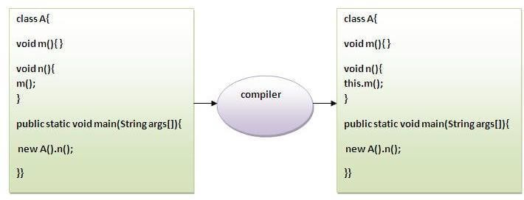

class A{
void m(){System.out.println("hello m");}


Test it Now
Output:

hello n hello m

this() : to invoke current class constructor

The this() constructor call can be used to invoke the current class constructor. It is used to reuse the constructor. In other words, it is used for constructor chaining.
Calling default constructor from parameterized constructor:

class A{ A(){System.out.println("hello a");}


Test it Now
Output:

hello a 10
Calling parameterized constructor from default constructor:

class A{ A(){


Test it Now
Output:

Real usage of this() constructor call

The this() constructor call should be used to reuse the constructor from the constructor. It maintains the chain between the constructors i.e. it is used for constructor chaining. Let's see the example given below that displays the actual use of this keyword.

class Student{ int rollno;


Test it Now
Output:

- ankit java 0.0
- sumit java 6000.0

Rule: Call to this() must be the first statement in constructor.

class Student{ int rollno;


Test it Now
Output:

Compile Time Error: Call to this must be first statement in constructor

this: to pass as an argument in the method

The this keyword can also be passed as an argument in the method. It is mainly used in the event handling. Let's see the example:

class S2{
void m(S2 obj){


Test it Now
Output:

Application of this that can be passed as an argument:

In event handling (or) in a situation where we have to provide reference of a class to another one. It is used to reuse one object in many methods.

this: to pass as argument in the constructor call

We can pass the this keyword in the constructor also. It is useful if we have to use one object in multiple classes. Let's see the example:

class B{ A4 obj;


Test it Now
Output:10

this keyword can be used to return current class instance

We can return this keyword as an statement from the method. In such case, return type of the method must be the class type (non-primitive). Let's see the example:
Syntax of this that can be returned as a statement

return_type method_name(){ return this;

Example of this keyword that you return as a statement from the method

class A{ A getA(){


Test it Now
Output:

Hello java

Proving this keyword

Let's prove that this keyword refers to the current class instance variable. In this program, we are printing the reference variable and this, output of both variables are same.

class A5{ void m(){


Test it Now
Output:

A5@22b3ea59 A5@22b3ea59

Inheritance in Java
Inheritance in Java is a mechanism in which one object acquires all the properties and behaviors of a parent object. It is an important part of OOPs (Object Oriented programming system).
The idea behind inheritance in Java is that you can create new classes that are built upon existing classes. When you inherit from an existing class, you can reuse methods and fields of the parent class. Moreover, you can add new methods and fields in your current class also.
Inheritance represents the IS-A relationship which is also known as a parent-child
relationship.

Why use inheritance in java

- For Method Overriding (so runtime polymorphism can be achieved).
- For Code Reusability.

Terms used in Inheritance

- Class: A class is a group of objects which have common properties. It is a template or blueprint from which objects are created.
- Sub Class/Child Class: Subclass is a class which inherits the other class. It is also called a derived class, extended class, or child class.
- Super Class/Parent Class: Superclass is the class from where a subclass inherits the features. It is also called a base class or a parent class.
- Reusability: As the name specifies, reusability is a mechanism which facilitates you to reuse the fields and methods of the existing class when you
create a new class. You can use the same fields and methods already defined in the previous class.

The syntax of Java Inheritance

class Subclass-name extends Superclass- name
The extends keyword indicates that you are making a new class that derives from an existing class. The meaning of "extends" is to increase the functionality.
In the terminology of Java, a class which is inherited is called a parent or superclass, and the new class is called child or subclass.

Java Inheritance Example
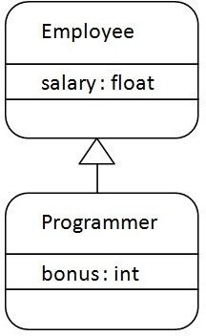
As displayed in the above figure, Programmer is the subclass and Employee is the superclass. The relationship between the two classes is Programmer IS-A Employee. It means that Programmer is a type of Employee.

class Employee{ float salary=40000;


Test it Now
Programmer salary is:40000.0 Bonus of programmer is:10000
In the above example, Programmer object can access the field of own class as well as of Employee class i.e. code reusability.

Types of inheritance in java
On the basis of class, there can be three types of inheritance in java: single, multilevel and hierarchical.
In java programming, multiple and hybrid inheritance is supported through interface only. We will learn about interfaces later.
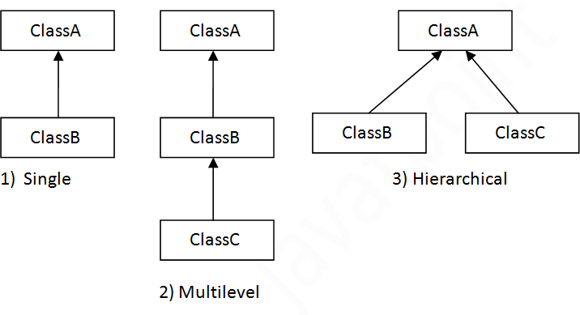

Note: Multiple inheritance is not supported in Java through class.
When one class inherits multiple classes, it is known as multiple inheritance. For Example:
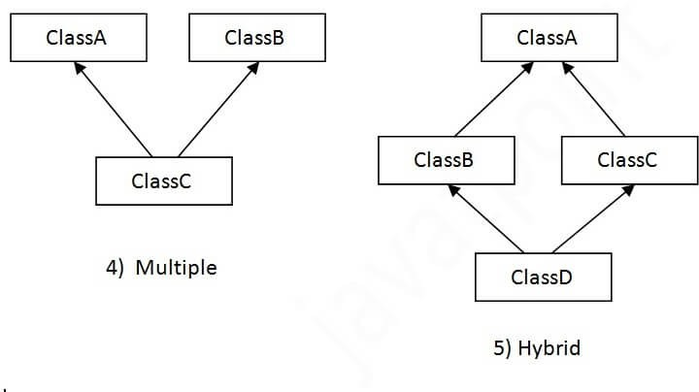

Single Inheritance Example
When a class inherits another class, it is known as a single inheritance. In the example given below, Dog class inherits the Animal class, so there is the single inheritance.
File: TestInheritance.java

class Animal{
void eat(){System.out.println("eating...");}
Output:
barking... eating...

Multilevel Inheritance Example
When there is a chain of inheritance, it is known as multilevel inheritance. As you can see in the example given below, BabyDog class inherits the Dog class which again inherits the Animal class, so there is a multilevel inheritance.
File: TestInheritance2.java

class Animal{
void eat(){System.out.println("eating...");}
Output:
weeping... barking... eating...

Hierarchical Inheritance Example
When two or more classes inherits a single class, it is known as hierarchical inheritance. In the example given below, Dog and Cat classes inherits the Animal class, so there is hierarchical inheritance.
File: TestInheritance3.java

class Animal{
void eat(){System.out.println("eating...");}
Output:
meowing... eating...

Aggregation in Java
If a class have an entity reference, it is known as Aggregation. Aggregation represents HAS-A relationship.
Consider a situation, Employee object contains many informations such as id, name, emailId etc. It contains one more object named address, which contains its own informations such as city, state, country, zipcode etc. as given below.

class Employee{
In such case, Employee has an entity reference address, so relationship is Employee HAS-A address.
Why use Aggregation?

- For Code Reusability.

Simple Example of Aggregation

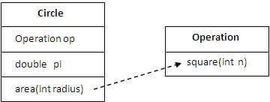

In this example, we have created the reference of Operation class in the Circle class.

class Operation{ int square(int n){
return n*n;
}
}

class Circle{

Operation op;//aggregation double pi=3.14;

double area(int radius){ op=new Operation();
int rsquare=op.square(radius);//code reusability (i.e. delegates the return pi*rsquare;
}

public static void main(String args[]){ Circle c=new Circle();
double result=c.area(5); System.out.println(result);
}
}

Test it Now

Output:78.5

When use Aggregation?

- Code reuse is also best achieved by aggregation when there is no is-a relationship.
- Inheritance should be used only if the relationship is-a is maintained throughout the lifetime of the objects involved; otherwise, aggregation is the best choice.

Method Overloading in Java
If a class has multiple methods having same name but different in parameters, it is known as Method Overloading.
If we have to perform only one operation, having same name of the methods increases the readability of the program.
Suppose you have to perform addition of the given numbers but there can be any number of arguments, if you write the method such as a(int,int) for two parameters, and b(int,int,int) for three parameters then it may be difficult for you as well as other programmers to understand the behavior of the method because its name differs.
So, we perform method overloading to figure out the program quickly.

Advantage of method overloading
Method overloading increases the readability of the program.

Different ways to overload the method
There are two ways to overload the method in java
  - By changing number of arguments
  - By changing the data type


In Java, Method Overloading is not possible by changing the return type of the method only.

Method Overloading: changing no. of arguments
In this example, we have created two methods, first add() method performs addition of two numbers and second add method performs addition of three numbers.
In this example, we are creating static methods so that we don't need to create instance for calling methods.

class Adder{
static int add(int a,int b){return a+b;}


Test it Now
Output:
22
33

Method Overloading: changing data type of arguments
In this example, we have created two methods that differs in data type. The first add method receives two integer arguments and second add method receives two double arguments.

class Adder{
static int add(int a, int b){return a+b;}


Test it Now
Output:
22
24.9

Why Method Overloading is not possible by changing the return type of method only?
In java, method overloading is not possible by changing the return type of the method only because of ambiguity. Let's see how ambiguity may occur:

class Adder{
static int add(int a,int b){return a+b;}


Test it Now
Output:

Compile Time Error: method add(int,int) is already defined in class Adder

System.out.println(Adder.add(11,11)); //Here, how can java determine which sum() method should be called?


Note: Compile Time Error is better than Run Time Error. So, java compiler renders compiler time error if you declare the same method having same parameters.

Can we overload java main() method?

Yes, by method overloading. You can have any number of main methods in a class by method overloading. But JVM calls main() method which receives string array as arguments only. Let's see the simple example:

class TestOverloading4{
public static void main(String[] args)


Test it Now
Output:
main with String[]

Method Overloading and Type Promotion
One type is promoted to another implicitly if no matching datatype is found. Let's understand the concept by the figure given below:
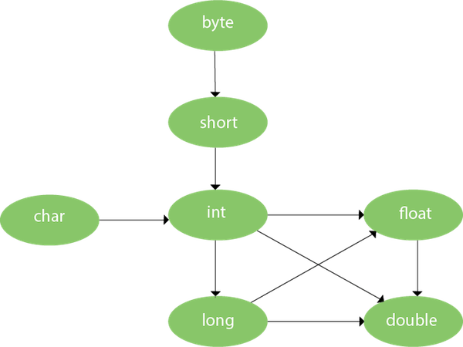
As displayed in the above diagram, byte can be promoted to short, int, long, float or double. The short datatype can be promoted to int, long, float or double. The char datatype can be promoted to int,long,float or double and so on.

Example of Method Overloading with TypePromotion

class OverloadingCalculation1{


Test it Now

Output:40
60

Method Overriding in Java
If subclass (child class) has the same method as declared in the parent class, it is known as method overriding in Java.
In other words, If a subclass provides the specific implementation of the method that has been declared by one of its parent class, it is known as method overriding.

Usage of Java Method Overriding

- Method overriding is used to provide the specific implementation of a method which is already provided by its superclass.
- Method overriding is used for runtime polymorphism

Rules for Java Method Overriding

  - The method must have the same name as in the parent class
  - The method must have the same parameter as in the parent class.
  - There must be an IS-A relationship (inheritance).
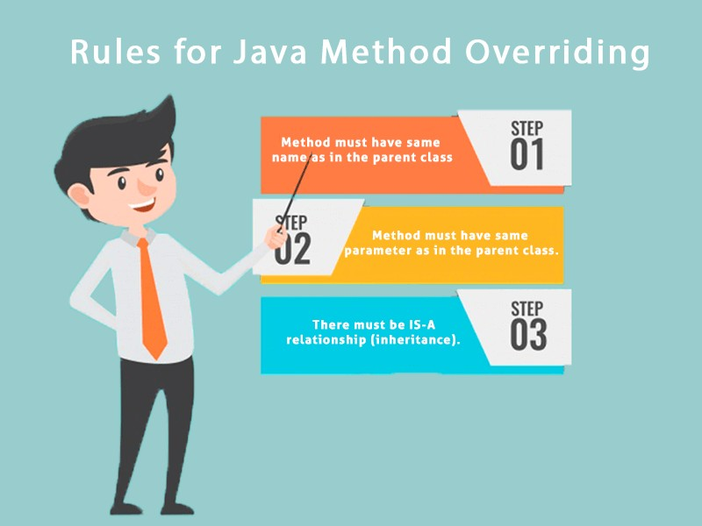

Understanding the problem without method overriding

Let's understand the problem that we may face in the program if we don't use method overriding.

//Java Program to demonstrate why we need method overriding


Test it Now
Output:
Vehicle is running
Problem is that I have to provide a specific implementation of run() method in subclass that is why we use method overriding.

Example of method overriding
In this example, we have defined the run method in the subclass as defined in the parent class but it has some specific implementation. The name and parameter of the method are the same, and there is IS-A relationship between the classes, so there is method overriding.

//Java Program to illustrate the use of Java Method Overriding


Test it Now
Output:
Bike is running safely

A real example of Java Method Overriding

Consider a scenario where Bank is a class that provides functionality to get the rate of interest. However, the rate of interest varies according to banks. For example, SBI, ICICI and AXIS banks could provide 8%, 7%, and 9% rate of interest.
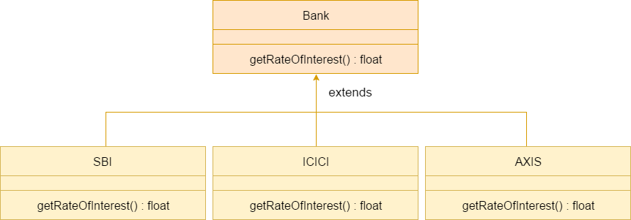


Java method overriding is mostly used in Runtime Polymorphism which we will learn in next pages.

//Java Program to demonstrate the real scenario of Java Method Overriding


Test it Now
Output:
SBI Rate of Interest: 8 ICICI Rate of Interest: 7 AXIS Rate of Interest: 9

Can we override static method?

No, a static method cannot be overridden. It can be proved by runtime polymorphism, so we will learn it later.

Why can we not override static method?

It is because the static method is bound with class whereas instance method is bound with an object. Static belongs to the class area, and an instance belongs to the heap area.

Can we override java main method?

No, because the main is a static method.

Difference between method Overloading and Method Overriding in java
Click me for the difference between method overloading and overriding

Covariant Return Type
The covariant return type specifies that the return type may vary in the same direction as the subclass.
Before Java5, it was not possible to override any method by changing the return type. But now, since Java5, it is possible to override method by changing the return type if subclass overrides any method whose return type is Non-Primitive but it changes its return type to subclass type. Let's take a simple example:


Note: If you are beginner to java, skip this topic and return to it after OOPs concepts.

Simple example of Covariant Return Type
FileName: B1.java

class A{
A get(){return this;}


Test it Now
Output:

welcome to covariant return type
As you can see in the above example, the return type of the get() method of A class is A but the return type of the get() method of B class is B. Both methods have different return type but it is method overriding. This is known as covariant return type.

Advantages of Covariant Return Type
Following are the advantages of the covariant return type.
- Covariant return type assists to stay away from the confusing type casts in the class hierarchy and makes the code more usable, readable, and maintainable.
- In the method overriding, the covariant return type provides the liberty to have more to the point return types.
- Covariant return type helps in preventing the run-time ClassCastExceptions on returns.
Let's take an example to understand the advantages of the covariant return type.
FileName: CovariantExample.java

class A1
{
Output:

Inside the class A1 Inside the class A2 Inside the class A3
Explanation: In the above program, class A3 inherits class A2, and class A2 inherits class A1. Thus, A1 is the parent of classes A2 and A3. Hence, any object of classes A2 and A3 is also of type A1. As the return type of the method foo() is the same in every class, we do not know the exact type of object the method is actually returning. We can only deduce that returned object will be of type A1, which is the most generic class. We can not say for sure that returned object will be of A2 or A3. It is where we need to do the typecasting to find out the specific type of object returned from the method foo(). It not only makes the code verbose; it also requires precision from the programmer to ensure that typecasting is done properly; otherwise, there are fair chances of getting the ClassCastException. To exacerbate it, think of a situation where the hierarchical structure goes down to 10 - 15 classes or even more, and in each class, the method foo() has the same return type. That is enough to give a nightmare to the reader and writer of the code.
The better way to write the above is:
FileName: CovariantExample.java

class A1
{
Output:

Inside the class A1 Inside the class A2 Inside the class A3
Explanation: In the above program, no typecasting is needed as the return type is specific. Hence, there is no confusion about knowing the type of object getting returned from the method foo(). Also, even if we write the code for the 10 - 15 classes, there would be no confusion regarding the return types of the methods. All this is possible because of the covariant return type.

How is Covariant return types implemented?

Java doesn't allow the return type-based overloading, but JVM always allows return type-based overloading. JVM uses the full signature of a method for lookup/ resolution. Full signature means it includes return type in addition to argument types. i.e., a class can have two or more methods differing only by return type. javac uses this fact to implement covariant return types.
Output:

The number 1 is not the powerful number. The number 2 is not the powerful number. The number 3 is not the powerful number. The number 4 is the powerful number.
The number 5 is not the powerful number. The number 6 is not the powerful number. The number 7 is not the powerful number. The number 8 is the powerful number.
The number 9 is the powerful number.
The | number | 10 | is | not | the powerful number.
The | number | 11 | is | not | the powerful number.
The | number | 12 | is | not | the powerful number.
The | number | 13 | is | not | the powerful number.
The | number | 14 | is | not | the powerful number.
The | number | 15 | is | not | the powerful number.
The | number | 16 | is | the | powerful number.
The | number | 17 | is | not | the powerful number.
The | number | 18 | is | not | the powerful number.
The | number | 19 | is | not | the powerful number.
The | number | 20 | is | the | powerful number.

Explanation: For every number from 1 to 20, the method isPowerfulNo() is invoked with the help of for-loop. For every number, a vector primeFactors is created for storing its prime divisors. Then, we check whether square of every number present in the vector primeFactors divides the number or not. If all square of all the number present in the vector primeFactors divides the number completely, the number is a powerful number; otherwise, not.

Super Keyword in Java
The super keyword in Java is a reference variable which is used to refer immediate parent class object.
Whenever you create the instance of subclass, an instance of parent class is created implicitly which is referred by super reference variable.

Usage of Java super Keyword

  - super can be used to refer immediate parent class instance variable.
  - super can be used to invoke immediate parent class method.
  - super() can be used to invoke immediate parent class constructor.
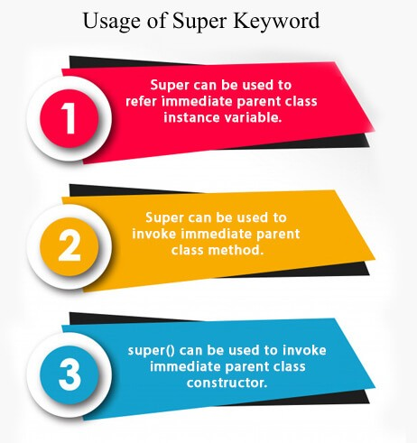

super is used to refer immediate parent class instance variable.
We can use super keyword to access the data member or field of parent class. It is used if parent class and child class have same fields.

class Animal{
String color="white";


Test it Now
Output:
black white
In the above example, Animal and Dog both classes have a common property color. If we print color property, it will print the color of current class by default. To access the parent property, we need to use super keyword.

super can be used to invoke parent class method
The super keyword can also be used to invoke parent class method. It should be used if subclass contains the same method as parent class. In other words, it is used if method is overridden.

class Animal{
void eat(){System.out.println("eating...");}


Test it Now
Output:
eating... barking...
In the above example Animal and Dog both classes have eat() method if we call eat() method from Dog class, it will call the eat() method of Dog class by default because priority is given to local.
To call the parent class method, we need to use super keyword.

super is used to invoke parent class constructor.
The super keyword can also be used to invoke the parent class constructor. Let's see a simple example:

class Animal{ Animal(){System.out.println("animal is


Test it Now
Output:

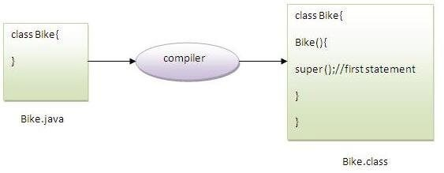
animal is created dog is created

Note: super() is added in each class constructor automatically by compiler if there is no super() or this().

As we know well that default constructor is provided by compiler automatically if there is no constructor. But, it also adds super() as the first statement.
Another example of super keyword where super() is provided by the compiler implicitly.

class Animal{ Animal(){System.out.println("animal is


Test it Now
Output:
animal is created dog is created

super example: real use
Let's see the real use of super keyword. Here, Emp class inherits Person class so all the properties of Person will be inherited to Emp by default. To initialize all the property, we are using parent class constructor from child class. In such way, we are reusing the parent class constructor.

class Person{ int id;


Test it Now
Output:
1 ankit 45000
Instance initializer block
Instance Initializer block is used to initialize the instance data member. It run each time when object of the class is created.
The initialization of the instance variable can be done directly but there can be performed extra operations while initializing the instance variable in the instance initializer block.
Que) What is the use of instance initializer block while we can directly assign a value in instance data member? For example:

class Bike{
int speed=100;

Why use instance initializer block?

Suppose I have to perform some operations while assigning value to instance data member e.g. a for loop to fill a complex array or error handling etc.

Example of instance initializer block
Let's see the simple example of instance initializer block that performs initialization.
class Bike7{ int speed;


Test it Now
Output:speed is 100
speed is 100

There are three places in java where you can perform operations:
  - method
  - constructor
  - block

What is invoked first, instance initializer block or constructor?

class Bike8{ int speed;


Test it Now

Output:instance initializer block invoked constructor is invoked
instance initializer block invoked constructor is invoked
In the above example, it seems that instance initializer block is firstly invoked but NO. Instance intializer block is invoked at the time of object creation. The java compiler copies the instance initializer block in the constructor after the first statement super(). So firstly, constructor is invoked. Let's understand it by the figure given below:
Note: The java compiler copies the code of instance initializer block in every constructor.
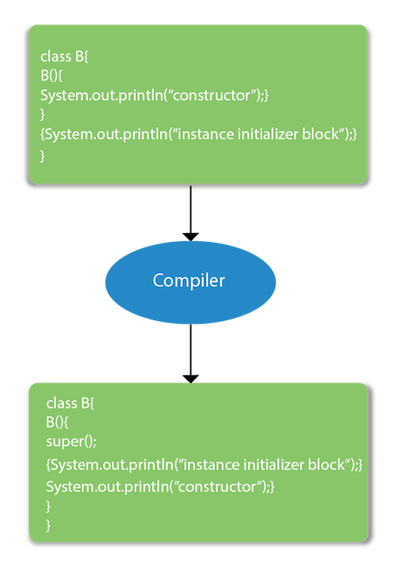

Rules for instance initializer block :
There are mainly three rules for the instance initializer block. They are as follows:
- The instance initializer block is created when instance of the class is created.
- The instance initializer block is invoked after the parent class constructor is invoked (i.e. after super() constructor call).
- The instance initializer block comes in the order in which they appear.

Program of instance initializer block that is invoked after super()

class A{ A(){


Test it Now

Output:parent class constructor invoked instance initializer block is invoked child class constructor invoked

Final Keyword In Java
The final keyword in java is used to restrict the user. The java final keyword can be used in many context. Final can be:
- variable
- method
- class
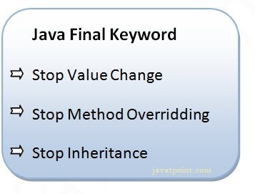
The final keyword can be applied with the variables, a final variable that have no value it is called blank final variable or uninitialized final variable. It can be initialized in the constructor only. The blank final variable can be static also which will be initialized in the static block only. We will have detailed learning of these. Let's first learn the basics of final keyword.

Java final variable
If you make any variable as final, you cannot change the value of final variable(It will be constant).

Example of final variable
There is a final variable speedlimit, we are going to change the value of this variable, but It can't be changed because final variable once assigned a value can never be changed.

class Bike9{
final int speedlimit=90;//final variable


Test it Now
Output:Compile Time Error

Java final method
If you make any method as final, you cannot override it.

Example of final method

class Bike{
final void run()


Test it Now

Output:Compile Time Error

Java final class
If you make any class as final, you cannot extend it.

Example of final class

final class Bike{}


Test it Now

Output:Compile Time Error

Q) Is final method inherited?

Ans) Yes, final method is inherited but you cannot override it. For Example:

class Bike{
final void run()


Test it Now
Output:running...

Q) What is blank or uninitialized final variable?

A final variable that is not initialized at the time of declaration is known as blank final variable.
If you want to create a variable that is initialized at the time of creating object and once initialized may not be changed, it is useful. For example PAN CARD number of an employee.
It can be initialized only in constructor.

Example of blank final variable

class Student{ int id;

Que) Can we initialize blank final variable?

Yes, but only in constructor. For example:

class Bike10{
final int speedlimit;//blank final variable


Test it Now
Output: 70

static blank final variable

A static final variable that is not initialized at the time of declaration is known as static blank final variable. It can be initialized only in static block.

Example of static blank final variable

class A{
static final int data;//static blank final

- What is final parameter?

If you declare any parameter as final, you cannot change the value of it.

class Bike11{
int cube(final int n){


Test it Now
Output: Compile Time Error

Polymorphism in Java
Polymorphism in Java is a concept by which we can perform a single action in different ways. Polymorphism is derived from 2 Greek words: poly and morphs. The word "poly" means many and "morphs" means forms. So polymorphism means many forms.
There are two types of polymorphism in Java: compile-time polymorphism and runtime polymorphism. We can perform polymorphism in java by method overloading and method overriding.
If you overload a static method in Java, it is the example of compile time polymorphism. Here, we will focus on runtime polymorphism in java.

Runtime Polymorphism in Java
Runtime polymorphism or Dynamic Method Dispatch is a process in which a call to an overridden method is resolved at runtime rather than compile-time.
In this process, an overridden method is called through the reference variable of a superclass. The determination of the method to be called is based on the object being referred to by the reference variable.
Let's first understand the upcasting before Runtime Polymorphism.

Upcasting

If the reference variable of Parent class refers to the object of Child class, it is known as upcasting. For example:
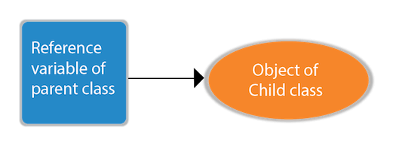

class A{}
class B extends A{}

A a=new B();//upcasting
For upcasting, we can use the reference variable of class type or an interface type. For Example:

interface I{} class A{}
Here, the relationship of B class would be:
B IS-A A B IS-A I
B IS-A Object
Since Object is the root class of all classes in Java, so we can write B IS-A Object.

Example of Java Runtime Polymorphism
In this example, we are creating two classes Bike and Splendor. Splendor class extends Bike class and overrides its run() method. We are calling the run method by the reference variable of Parent class. Since it refers to the subclass object and subclass method overrides the Parent class method, the subclass method is invoked at runtime.
Since method invocation is determined by the JVM not compiler, it is known as runtime polymorphism.

class Bike{ void run()


Test it Now
Output:
running safely with 60km.

Java Runtime Polymorphism Example: Bank
Consider a scenario where Bank is a class that provides a method to get the rate of interest. However, the rate of interest may differ according to banks. For example, SBI, ICICI, and AXIS banks are providing 8.4%, 7.3%, and 9.7% rate of interest.



Note: This example is also given in method overriding but there was no upcasting.

class Bank{
float getRateOfInterest(){return 0;}


Test it Now
Output:
SBI Rate of Interest: 8.4 ICICI Rate of Interest: 7.3 AXIS Rate of Interest: 9.7

Java Runtime Polymorphism Example: Shape

class Shape{ void draw()


Test it Now
Output:
drawing rectangle... drawing circle... drawing triangle...

Java Runtime Polymorphism Example: Animal

class Animal{
void eat(){System.out.println("eating...");}


Test it Now
Output:
eating bread... eating rat... eating meat...

Java Runtime Polymorphism with Data Member
A method is overridden, not the data members, so runtime polymorphism can't be achieved by data members.
In the example given below, both the classes have a data member speedlimit. We are accessing the data member by the reference variable of Parent class which refers to the subclass object. Since we are accessing the data member which is not overridden, hence it will access the data member of the Parent class always.

Rule: Runtime polymorphism can't be achieved by data members.

class Bike{
int speedlimit=90;


Test it Now
Output:
90

Java Runtime Polymorphism with Multilevel Inheritance
Let's see the simple example of Runtime Polymorphism with multilevel inheritance.

class Animal{
void eat(){System.out.println("eating");}


Test it Now
Output:
eating
eating fruits drinking Milk

Static Binding and Dynamic Binding

Connecting a method call to the method body is known as binding.
There are two types of binding
  - Static Binding (also known as Early Binding).
  - Dynamic Binding (also known as Late Binding).
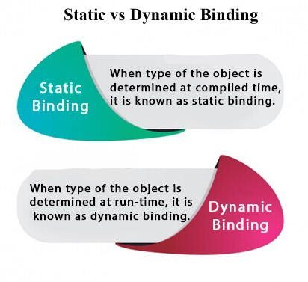

Understanding Type

Let's understand the type of instance.
- variables have a type

Each variable has a type, it may be primitive and non-primitive.

int data=30;
Here data variable is a type of int.
- References have a type

class Dog{

- Objects have a type

An object is an instance of particular java class,but it is also an instance of its superclass.
class Animal{}
Here d1 is an instance of Dog class, but it is also an instance of Animal.

static binding

When type of the object is determined at compiled time(by the compiler), it is known as static binding.
If there is any private, final or static method in a class, there is static binding.

Example of static binding

class Dog{ private void eat()

Java instanceof
The java instanceof operator is used to test whether the object is an instance of the specified type (class or subclass or interface).
The instanceof in java is also known as type comparison operator because it compares the instance with type. It returns either true or false. If we apply the instanceof operator with any variable that has null value, it returns false.

Simple example of java instanceof
Let's see the simple example of instance operator where it tests the current class.

class Simple1{
public static void main(String args[]){


Test it Now
Output:true

An object of subclass type is also a type of parent class. For example, if Dog extends Animal then object of Dog can be referred by either Dog or Animal class.

Another example of java instanceof operator

class Animal{}
class Dog1 extends Animal{//Dog inherits


Test it Now

Output:true

instanceof in java with a variable that have null value
If we apply instanceof operator with a variable that have null value, it returns false. Let's see the example given below where we apply instanceof operator with the variable that have null value.

class Dog2{
public static void main(String args[]){


Test it Now
Output:false

Downcasting with java instanceof operator
When Subclass type refers to the object of Parent class, it is known as downcasting. If we perform it directly, compiler gives Compilation error. If you perform it by typecasting, ClassCastException is thrown at runtime. But if we use instanceof operator, downcasting is possible.

Dog d=new Animal();//Compilation error
If we perform downcasting by typecasting, ClassCastException is thrown at runtime.

Dog d=(Dog)new Animal();
//Compiles successfully but

Possibility of downcasting with instanceof

Let's see the example, where downcasting is possible by instanceof operator.

class Animal { }


Test it Now
Output:ok downcasting performed

Abstract class in Java
A class which is declared with the abstract keyword is known as an abstract class in Java. It can have abstract and non-abstract methods (method with the body).
Before learning the Java abstract class, let's understand the abstraction in Java first.

Abstraction in Java

Abstraction is a process of hiding the implementation details and showing only functionality to the user.
Another way, it shows only essential things to the user and hides the internal details, for example, sending SMS where you type the text and send the message. You don't know the internal processing about the message delivery.
Abstraction lets you focus on what the object does instead of how it does it.
Ways to achieve Abstraction

There are two ways to achieve abstraction in java
  - Abstract class (0 to 100%)
  - Interface (100%)

Abstract class in Java

A class which is declared as abstract is known as an abstract class. It can have abstract and non-abstract methods. It needs to be extended and its method implemented. It cannot be instantiated.
Points to Remember

    - An abstract class must be declared with an abstract keyword.
    - It can have abstract and non-abstract methods.
    - It cannot be instantiated.
    - It can have constructors and static methods also.
    - It can have final methods which will force the subclass not to change the body of the method.
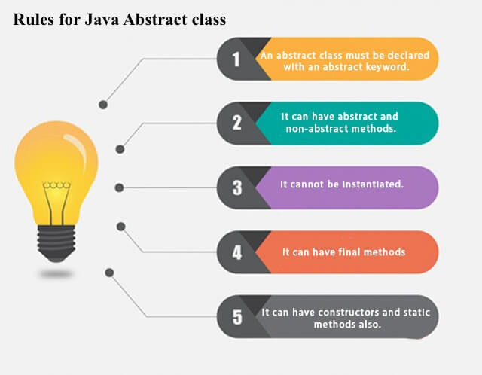

Example of abstract class

abstract class A{}

Abstract Method in Java

A method which is declared as abstract and does not have implementation is known as an abstract method.
Example of abstract method

abstract void printStatus();//no method body and abstract

Example of Abstract class that has an abstract method
In this example, Bike is an abstract class that contains only one abstract method run. Its implementation is provided by the Honda class.

abstract class Bike{ abstract void run();


Test it Now
running safely

Understanding the real scenario of Abstract class

In this example, Shape is the abstract class, and its implementation is provided by the Rectangle and Circle classes.
Mostly, we don't know about the implementation class (which is hidden to the end user), and an object of the implementation class is provided by the factory method.
A factory method is a method that returns the instance of the class. We will learn about the factory method later.
In this example, if you create the instance of Rectangle class, draw() method of Rectangle class will be invoked.
File: TestAbstraction1.java

abstract class Shape{ abstract void draw();


Test it Now
drawing circle

Another example of Abstract class in java

File: TestBank.java

abstract class Bank{
abstract int getRateOfInterest();


Test it Now
Rate of Interest is: 7 % Rate of Interest is: 8 %

Abstract class having constructor, data member and methods
An abstract class can have a data member, abstract method, method body (non- abstract method), constructor, and even main() method.
File: TestAbstraction2.java

//Example of an abstract class that has abstract and non-abstract methods


Test it Now
bike is created running safely.. gear changed

class Bike12{ abstract void run();


Test it Now
compile time error


Rule: If you are extending an abstract class that has an abstract method, you must either provide the implementation of the method or make this class abstract.

Interface in Java
An interface in Java is a blueprint of a class. It has static constants and abstract methods.
The interface in Java is a mechanism to achieve abstraction. There can be only abstract methods in the Java interface, not method body. It is used to achieve abstraction and multiple inheritance in Java.
In other words, you can say that interfaces can have abstract methods and variables. It cannot have a method body.
Java Interface also represents the IS-A relationship. It cannot be instantiated just like the abstract class.
Since Java 8, we can have default and static methods in an interface. Since Java 9, we can have private methods in an interface.

Why use Java interface?
There are mainly three reasons to use interface. They are given below.
- It is used to achieve abstraction.
- By interface, we can support the functionality of multiple inheritance.
- It can be used to achieve loose coupling.
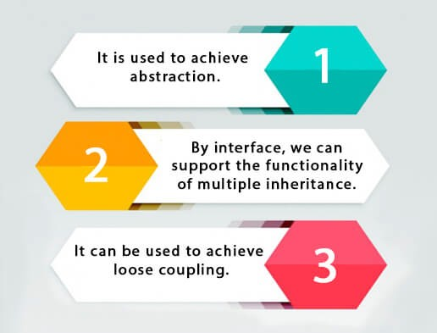

How to declare an interface?
An interface is declared by using the interface keyword. It provides total abstraction; means all the methods in an interface are declared with the empty body, and all the fields are public, static and final by default. A class that implements an interface must implement all the methods declared in the interface.

Syntax:

interface <interface_name>{

Java 8 Interface Improvement
Since Java 8, interface can have default and static methods which is discussed later.

Internal addition by the compiler


The Java compiler adds public and abstract keywords before the interface method. Moreover, it adds public, static and final keywords before data members.

In other words, Interface fields are public, static and final by default, and the methods are public and abstract.
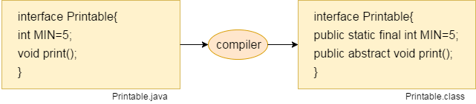

The relationship between classes and interfaces

As shown in the figure given below, a class extends another class, an interface extends another interface, but a class implements an interface.
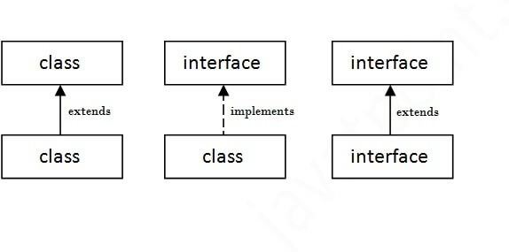

Java Interface Example
In this example, the Printable interface has only one method, and its implementation is provided in the A6 class.

interface printable{ void print();


Test it Now
Output:
Hello

Java Interface Example: Drawable
In this example, the Drawable interface has only one method. Its implementation is provided by Rectangle and Circle classes. In a real scenario, an interface is defined by someone else, but its implementation is provided by different implementation providers. Moreover, it is used by someone else. The implementation part is hidden by the user who uses the interface.
File: TestInterface1.java

//Interface declaration: by first user interface Drawable{


Test it Now
Output:
drawing circle

Java Interface Example: Bank
Let's see another example of java interface which provides the implementation of Bank interface.
File: TestInterface2.java

interface Bank{
float rateOfInterest();


Test it Now
Output:
ROI: 9.15

Multiple inheritance in Java by interface
If a class implements multiple interfaces, or an interface extends multiple interfaces, it is known as multiple inheritance.
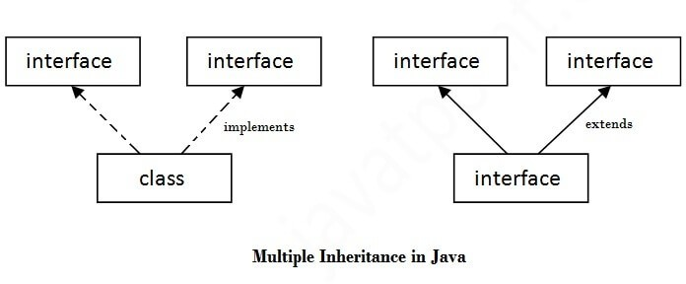

interface Printable{ void print();


Test it Now
Output:Hello
Welcome

Q) Multiple inheritance is not supported through class in java, but it is possible by an interface, why?
As we have explained in the inheritance chapter, multiple inheritance is not supported in the case of class because of ambiguity. However, it is supported in case of an interface because there is no ambiguity. It is because its implementation is provided by the implementation class. For example:

interface Printable{ void print();


Test it Now
Output:
Hello
As you can see in the above example, Printable and Showable interface have same methods but its implementation is provided by class TestTnterface1, so there is no ambiguity.

Interface inheritance
A class implements an interface, but one interface extends another interface.

interface Printable{ void print();


Test it Now
Output:
Hello Welcome

Java 8 Default Method in Interface
Since Java 8, we can have method body in interface. But we need to make it default method. Let's see an example:
File: TestInterfaceDefault.java

interface Drawable{ void draw();


Test it Now
Output:
drawing rectangle default method

Java 8 Static Method in Interface
Since Java 8, we can have static method in interface. Let's see an example:
File: TestInterfaceStatic.java

interface Drawable{ void draw();


Test it Now
Output:

Q) What is marker or tagged interface?
An interface which has no member is known as a marker or tagged interface, for example, Serializable, Cloneable, Remote, etc. They are used to provide some essential information to the JVM so that JVM may perform some useful operation.

//How Serializable interface is written? public interface Serializable{

Difference between abstract class and interface
Abstract class and interface both are used to achieve abstraction where we can declare the abstract methods. Abstract class and interface both can't be instantiated.
But there are many differences between abstract class and interface that are given below.

Abstract class | Interface
1) Abstract class can have abstract and non-abstract methods. | Interface can have only abstract methods. Since Java 8, it can have default and static methods also.
2) Abstract class doesn't support multiple inheritance. | Interface supports multiple inheritance.
3) Abstract class can have final, non- final, static and non-static variables. | Interface has only static and final variables.
4) Abstract class can provide the implementation of interface. | Interface can't provide the implementation of abstract class.
5) The abstract keyword is used to declare abstract class. | The interface keyword is used to declare interface.
6) An abstract class can extend another Java class and implement multiple Java interfaces. | An interface can extend another Java interface only.
7) An abstract class can be extended using keyword "extends". | An interface can be implemented using keyword "implements".
8) A Java abstract class can have class members like private, protected, etc. | Members of a Java interface are public by default.
9)Example:  public abstract class Shape{ public abstract void draw();  } | Example:  public interface Drawable{ void draw();  }
Simply, abstract class achieves partial abstraction (0 to 100%) whereas interface achieves fully abstraction (100%).

Example of abstract class and interface in Java

Let's see a simple example where we are using interface and abstract class both.

//Creating interface that has 4 methods interface A{


Test it Now
Output:
I am a I am b I am c I am d
Java Package
A java package is a group of similar types of classes, interfaces and sub-packages.
Package in java can be categorized in two form, built-in package and user-defined package.
There are many built-in packages such as java, lang, awt, javax, swing, net, io, util, sql etc.
Here, we will have the detailed learning of creating and using user-defined packages.
Advantage of Java Package

- Java package is used to categorize the classes and interfaces so that they can be easily maintained.
- Java package provides access protection.
- Java package removes naming collision.
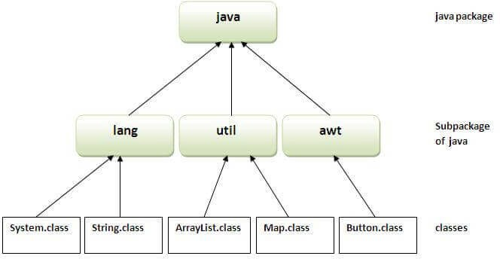

Simple example of java package
The package keyword is used to create a package in java.

//save as Simple.java package mypack;
How to compile java package

If you are not using any IDE, you need to follow the syntax given below:

javac -d directory javafilename
For example

javac -d . Simple.java

The -d switch specifies the destination where to put the generated class file. You can use any directory name like /home (in case of Linux), d:/abc (in case of windows) etc. If you want to keep the package within the same directory, you can use . (dot).

How to run java package program

You need to use fully qualified name e.g. mypack.Simple etc to run the class.

To Compile: javac -d . Simple.java
To Run: java mypack.Simple
Output:Welcome to package
The -d is a switch that tells the compiler where to put the class file i.e. it represents destination. The . represents the current folder.

How to access package from another package?
There are three ways to access the package from outside the package.
  - import package.*;
  - import package.classname;
  - fully qualified name.

Using packagename.*

If you use package.* then all the classes and interfaces of this package will be accessible but not subpackages.
The import keyword is used to make the classes and interface of another package accessible to the current package.
Example of package that import the packagename.*

//save by A.java package pack;

//save by B.java package mypack;

Output:Hello

Using packagename.classname

If you import package.classname then only declared class of this package will be accessible.
Example of package by import package.classname

//save by A.java

//save by B.java package mypack;

Output:Hello

Using fully qualified name

If you use fully qualified name then only declared class of this package will be accessible. Now there is no need to import. But you need to use fully qualified name every time when you are accessing the class or interface.
It is generally used when two packages have same class name e.g. java.util and java.sql packages contain Date class.

Example of package by import fully qualified name

//save by A.java package pack;

//save by B.java package mypack;

Output:Hello

Note: If you import a package, subpackages will not be imported.

If you import a package, all the classes and interface of that package will be imported excluding the classes and interfaces of the subpackages. Hence, you need to import the subpackage as well.

Note: Sequence of the program must be package then import then class.

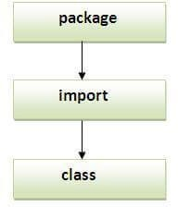

Subpackage in java
Package inside the package is called the subpackage. It should be created to categorize the package further.
Let's take an example, Sun Microsystem has definded a package named java that contains many classes like System, String, Reader, Writer, Socket etc. These classes represent a particular group e.g. Reader and Writer classes are for Input/Output operation, Socket and ServerSocket classes are for networking etc and so on. So, Sun has subcategorized the java package into subpackages such as lang, net, io etc. and put the Input/Output related classes in io package, Server and ServerSocket classes in net packages and so on.


The standard of defining package is domain.company.package e.g. com.javatpoint.bean or org.sssit.dao.

Example of Subpackage

package com.javatpoint.core; class Simple{
To Compile: javac -d . Simple.java
To Run: java com.javatpoint.core.Simple
Output:Hello subpackage

How to send the class file to another directory or drive?
There is a scenario, I want to put the class file of A.java source file in classes folder of c: drive. For example:
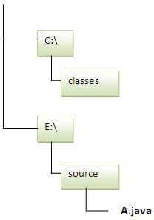

//save as Simple.java package mypack;
To Compile:

e:\sources> javac -d c:\classes Simple.java
To Run:

To run this program from e:\source directory, you need to set classpath of the directory where the class file resides.
e:\sources> set classpath=c:\classes;.; e:\sources> java mypack.Simple

Another way to run this program by -classpath switch of java:

The -classpath switch can be used with javac and java tool.
To run this program from e:\source directory, you can use -classpath switch of java that tells where to look for class file. For example:
e:\sources> java -classpath c:\classes mypack.Simple

Output:Welcome to package

Ways to load the class files or jar files

There are two ways to load the class files temporary and permanent.
- Temporary
  - By setting the classpath in the command prompt
  - By -classpath switch
- Permanent
  - By setting the classpath in the environment variables
  - By creating the jar file, that contains all the class files, and copying the jar file in the jre/lib/ext folder.


Rule: There can be only one public class in a java source file and it must be saved by the public class name.

//save as C.java otherwise Compilte Time Error

How to put two public classes in a package?

If you want to put two public classes in a package, have two java source files containing one public class, but keep the package name same. For example:
//save as A.java

//save as B.java

What is static import feature of Java5?

Click Static Import feature of Java5.

Access Modifiers in Java
There are two types of modifiers in Java: access modifiers and non-access modifiers.
The access modifiers in Java specifies the accessibility or scope of a field, method, constructor, or class. We can change the access level of fields, constructors, methods, and class by applying the access modifier on it.
There are four types of Java access modifiers:
  - Private: The access level of a private modifier is only within the class. It cannot be accessed from outside the class.
  - Default: The access level of a default modifier is only within the package. It cannot be accessed from outside the package. If you do not specify any access level, it will be the default.
  - Protected: The access level of a protected modifier is within the package and outside the package through child class. If you do not make the child class, it cannot be accessed from outside the package.
  - Public: The access level of a public modifier is everywhere. It can be accessed from within the class, outside the class, within the package and outside the package.
There are many non-access modifiers, such as static, abstract, synchronized, native, volatile, transient, etc. Here, we are going to learn the access modifiers only.

Understanding Java Access Modifiers

Let's understand the access modifiers in Java by a simple table.

Access Modifier | within class | within package | outside package by subclass only | outside package
Private | Y | N | N | N
Default | Y | Y | N | N
Protected | Y | Y | Y | N
Public | Y | Y | Y | Y

Private

The private access modifier is accessible only within the class.
Simple example of private access modifier
In this example, we have created two classes A and Simple. A class contains private data member and private method. We are accessing these private members from outside the class, so there is a compile-time error.

class A{
private int data=40;

Role of Private Constructor

If you make any class constructor private, you cannot create the instance of that class from outside the class. For example:

class A{
private A(){}//private constructor

Note: A class cannot be private or protected except nested class.

Default

If you don't use any modifier, it is treated as default by default. The default modifier is accessible only within package. It cannot be accessed from outside the package. It provides more accessibility than private. But, it is more restrictive than protected, and public.
Example of default access modifier
In this example, we have created two packages pack and mypack. We are accessing the A class from outside its package, since A class is not public, so it cannot be accessed from outside the package.

//save by A.java package pack;

//save by B.java package mypack;
In the above example, the scope of class A and its method msg() is default so it cannot be accessed from outside the package.

Protected

The protected access modifier is accessible within package and outside the package but through inheritance only.
The protected access modifier can be applied on the data member, method and constructor. It can't be applied on the class.
It provides more accessibility than the default modifer.
Example of protected access modifier
In this example, we have created the two packages pack and mypack. The A class of pack package is public, so can be accessed from outside the package. But msg method of this package is declared as protected, so it can be accessed from outside the class only through inheritance.

//save by A.java package pack;

//save by B.java package mypack;
Output:Hello

Public

The public access modifier is accessible everywhere. It has the widest scope among all other modifiers.
Example of public access modifier

//save by A.java

//save by B.java

Output:Hello

Encapsulation in Java
Encapsulation in Java is a process of wrapping code and data together into a single unit, for example, a capsule which is mixed of several medicines.

We can create a fully encapsulated class in Java by making all the data members of the class private. Now we can use setter and getter methods to set and get the data in it.
The Java Bean class is the example of a fully encapsulated class.

Advantage of Encapsulation in Java

By providing only a setter or getter method, you can make the class read-only or write-only. In other words, you can skip the getter or setter methods.
It provides you the control over the data. Suppose you want to set the value of id which should be greater than 100 only, you can write the logic inside the setter method. You can write the logic not to store the negative numbers in the setter methods.
It is a way to achieve data hiding in Java because other class will not be able to access the data through the private data members.
The encapsulate class is easy to test. So, it is better for unit testing.
The standard IDE's are providing the facility to generate the getters and setters. So, it is easy and fast to create an encapsulated class in Java.

Simple Example of Encapsulation in Java
Let's see the simple example of encapsulation that has only one field with its setter and getter methods.
File: Student.java

//A Java class which is a fully encapsulated class.
File: Test.java

//A Java class to test the encapsulated class.
Compile By: javac -d . Test.java Run By: java com.javatpoint.Test
Output:
vijay

Read-Only class

//A Java class which has only getter methods.
Now, you can't change the value of the college data member which is "AKG".

s.setCollege("KITE");//will render compile time error

Write-Only class

//A Java class which has only setter methods.
Now, you can't get the value of the college, you can only change the value of college data member.

System.out.println(s.getCollege());// Compile Time Error, because there is no

Another Example of Encapsulation in Java
Let's see another example of encapsulation that has only four fields with its setter and getter methods.
File: Account.java

//A Account class which is a fully encapsulated class.
File: TestAccount.java

//A Java class to test the encapsulated class Account.


Test it Now
Output:
7560504000 Sonoo Jaiswal [email protected] 500000.0
Java Arrays
Normally, an array is a collection of similar type of elements which has contiguous memory location.
Java array is an object which contains elements of a similar data type. Additionally, The elements of an array are stored in a contiguous memory location. It is a data structure where we store similar elements. We can store only a fixed set of elements in a Java array.
Array in Java is index-based, the first element of the array is stored at the 0th index, 2nd element is stored on 1st index and so on.
Unlike C/C++, we can get the length of the array using the length member. In C/C++, we need to use the sizeof operator.
In Java, array is an object of a dynamically generated class. Java array inherits the Object class, and implements the Serializable as well as Cloneable interfaces. We can store primitive values or objects in an array in Java. Like C/C++, we can also create single dimentional or multidimentional arrays in Java.
Moreover, Java provides the feature of anonymous arrays which is not available in C/C++.
Java array

Advantages

- Code Optimization: It makes the code optimized, we can retrieve or sort the data efficiently.
- Random access: We can get any data located at an index position.

Disadvantages

- Size Limit: We can store only the fixed size of elements in the array. It doesn't grow its size at runtime. To solve this problem, collection framework is used in Java which grows automatically.

Types of Array in java

There are two types of array.
- Single Dimensional Array
- Multidimensional Array

Single Dimensional Array in Java
Syntax to Declare an Array in Java

dataType[] arr; (or) dataType []arr; (or)
Instantiation of an Array in Java

arrayRefVar=new datatype[size];

Example of Java Array
Let's see the simple example of java array, where we are going to declare, instantiate, initialize and traverse an array.

//Java Program to illustrate how to declare, instantiate, initialize


Test it Now
Output:
10
20
70
40
50

Declaration, Instantiation and Initialization of Java Array
We can declare, instantiate and initialize the java array together by:

int a[]={33,3,4,5};//declaration, instantiation and initialization
Let's see the simple example to print this array.

//Java Program to illustrate the use of declaration, instantiation


Test it Now
Output:
33
3
4
5

For-each Loop for Java Array
We can also print the Java array using for-each loop. The Java for-each loop prints the array elements one by one. It holds an array element in a variable, then executes the body of the loop.
The syntax of the for-each loop is given below:

for(data_type variable:array){
//body of the loop
Let us see the example of print the elements of Java array using the for-each loop.

//Java Program to print the array elements using for-each loop
Output:
33
3
4
5

Passing Array to a Method in Java
We can pass the java array to method so that we can reuse the same logic on any array.
Let's see the simple example to get the minimum number of an array using a method.

//Java Program to demonstrate the way of passing an array


Test it Now
Output:
3

Anonymous Array in Java
Java supports the feature of an anonymous array, so you don't need to declare the array while passing an array to the method.

//Java Program to demonstrate the way of passing an anonymous array


Test it Now
Output:
10
22
44
66

Returning Array from the Method
We can also return an array from the method in Java.

//Java Program to return an array from the method


Test it Now
Output:
10
30
50
90
60

ArrayIndexOutOfBoundsException
The Java Virtual Machine (JVM) throws an ArrayIndexOutOfBoundsException if length of the array in negative, equal to the array size or greater than the array size while traversing the array.

//Java Program to demonstrate the case of


Test it Now
Output:

Exception in thread "main" java.lang.ArrayIndexOutOfBoundsException: 4 at TestArrayException.main(TestArrayException.java:5)
50
60
70
80

Multidimensional Array in Java
In such case, data is stored in row and column based index (also known as matrix form).
Syntax to Declare Multidimensional Array in Java

dataType[][] arrayRefVar; (or) dataType [][]arrayRefVar; (or)
Example to instantiate Multidimensional Array in Java

int[][] arr=new int[3][3];//3 row and 3 column
Example to initialize Multidimensional Array in Java

arr[0][0]=1;
arr[0][1]=2;

Example of Multidimensional Java Array
Let's see the simple example to declare, instantiate, initialize and print the 2Dimensional array.

//Java Program to illustrate the use of multidimensional array


Test it Now
Output:
1 2 3
2 4 5
4 4 5

Jagged Array in Java
If we are creating odd number of columns in a 2D array, it is known as a jagged array. In other words, it is an array of arrays with different number of columns.

//Java Program to illustrate the jagged array


Test it Now
Output:
0 1 2
3 4 5 6
7 8

What is the class name of Java array?
In Java, an array is an object. For array object, a proxy class is created whose name can be obtained by getClass().getName() method on the object.

//Java Program to get the class name of array in Java


Test it Now
Output:
I

Copying a Java Array
We can copy an array to another by the arraycopy() method of System class.
Syntax of arraycopy method

public static void arraycopy(
Object src, int srcPos,Object dest, int

Example of Copying an Array in Java

//Java Program to copy a source array into a destination array in Java


Test it Now
Output:
caffein

Object class in Java
The Object class is the parent class of all the classes in java by default. In other words, it is the topmost class of java.
The Object class is beneficial if you want to refer any object whose type you don't know. Notice that parent class reference variable can refer the child class object, know as upcasting.
Let's take an example, there is getObject() method that returns an object but it can be of any type like Employee,Student etc, we can use Object class reference to refer that object. For example:

Object obj=getObject();//we don't know what object will be returned from this
The Object class provides some common behaviors to all the objects such as object can be compared, object can be cloned, object can be notified etc.

object class in java

Methods of Object class

The Object class provides many methods. They are as follows:
Method | Description
public final Class getClass() | returns the Class class object of this object. The Class class can further be used to get the metadata of this class.
public int hashCode() | returns the hashcode number for this object.
public boolean equals(Object obj) | compares the given object to this object.
protected Object clone() throws CloneNotSupportedException | creates and returns the exact copy (clone) of this object.
public String toString() | returns the string representation of this object.
public final void notify() | wakes up single thread, waiting on this object's monitor.
public final void notifyAll() | wakes up all the threads, waiting on this object's monitor.
public final void wait(long timeout)throws InterruptedException | causes the current thread to wait for the specified milliseconds, until another thread notifies (invokes notify() or notifyAll() method).
public final void wait(long timeout,int nanos)throws InterruptedException | causes the current thread to wait for the specified milliseconds and nanoseconds, until another thread notifies (invokes notify() or notifyAll() method).
public final void wait()throws InterruptedException | causes the current thread to wait, until another thread notifies (invokes notify() or notifyAll() method).
protected void finalize()throws Throwable | is invoked by the garbage collector before object is being garbage collected.

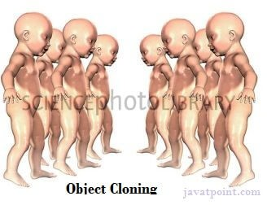
We will have the detailed learning of these methods in next chapters. Object Cloning in Java
The object cloning is a way to create exact copy of an object. The clone() method of Object class is used to clone an object.
The java.lang.Cloneable interface must be implemented by the class whose object clone we want to create. If we don't implement Cloneable interface, clone() method

generates CloneNotSupportedException.
The clone() method is defined in the Object class. Syntax of the clone() method is as follows:

protected Object clone() throws
Why use clone() method ?

The clone() method saves the extra processing task for creating the exact copy of an object. If we perform it by using the new keyword, it will take a lot of processing time to be performed that is why we use object cloning.
Advantage of Object cloning

Although Object.clone() has some design issues but it is still a popular and easy way of copying objects. Following is a list of advantages of using clone() method:
- You don't need to write lengthy and repetitive codes. Just use an abstract class with a 4- or 5-line long clone() method.
- It is the easiest and most efficient way for copying objects, especially if we are applying it to an already developed or an old project. Just define a parent class, implement Cloneable in it, provide the definition of the clone() method and the task will be done.
- Clone() is the fastest way to copy array.
Disadvantage of Object cloning

Following is a list of some disadvantages of clone() method:
- To use the Object.clone() method, we have to change a lot of syntaxes to our code, like implementing a Cloneable interface, defining the clone() method and handling CloneNotSupportedException, and finally, calling Object.clone() etc.
- We have to implement cloneable interface while it doesn't have any methods in it. We just have to use it to tell the JVM that we can perform clone() on our object.
- Object.clone() is protected, so we have to provide our own clone() and indirectly call Object.clone() from it.
- Object.clone() doesn't invoke any constructor so we don't have any control over object construction.
- If you want to write a clone method in a child class then all of its superclasses should define the clone() method in them or inherit it from another parent class. Otherwise, the super.clone() chain will fail.
- Object.clone() supports only shallow copying but we will need to override it if we need deep cloning.

Example of clone() method (Object cloning)
Let's see the simple example of object cloning

class Student18 implements Cloneable{


Test it Now
Output:101 amit
101 amit
download the example of object cloning
As you can see in the above example, both reference variables have the same value. Thus, the clone() copies the values of an object to another. So we don't need to write explicit code to copy the value of an object to another.
If we create another object by new keyword and assign the values of another object to this one, it will require a lot of processing on this object. So to save the extra processing task we use clone() method.
Java Math class
Java Math class provides several methods to work on math calculations like min(), max(), avg(), sin(), cos(), tan(), round(), ceil(), floor(), abs() etc.
Unlike some of the StrictMath class numeric methods, all implementations of the equivalent function of Math class can't define to return the bit-for-bit same results. This relaxation permits implementation with better-performance where strict reproducibility is not required.
If the size is int or long and the results overflow the range of value, the methods addExact(),ÝsubtractExact(),ÝmultiplyExact(), andÝtoIntExact()Ýthrow anÝArithmeticException.
For other arithmetic operations like increment, decrement, divide, absolute value, and negation overflowÝoccur only with a specific minimum or maximum value. It should be checked against the maximum and minimum value as appropriate.

Example 1

public class JavaMathExample1
{


Test it Now
Output:

Maximum number of x and y is: 28.0 Square root of y is: 2.0
Power of x and y is: 614656.0 Logarithm of x is: 3.332204510175204 Logarithm of y is: 1.3862943611198906 log10 of x is: 1.4471580313422192 log10 of y is: 0.6020599913279624
log1p of x is: 3.367295829986474
exp of a is: 1.446257064291475E12 expm1 of a is: 1.446257064290475E12

Example 2

public class JavaMathExample2
{


Test it Now
Output:

Sine value of a is: -0.9880316240928618 Cosine value of a is: 0.15425144988758405 Tangent value of a is: -6.405331196646276 Sine value of a is: NaN
Cosine value of a is: NaN
Tangent value of a is: 1.5374753309166493 Sine value of a is: 5.343237290762231E12 Cosine value of a is: 5.343237290762231E12 Tangent value of a is: 1.0

Java Math Methods
The java.lang.Math class contains various methods for performing basic numeric operations such as the logarithm, cube root, and trigonometric functions etc. The various java math methods are as follows:
Basic Math methods

Method | Description
Math.abs() | It will return the Absolute value of the given value.
Math.max() | It returns the Largest of two values.
Math.min() | It is used to return the Smallest of two values.
Math.round() | It is used to round of the decimal numbers to the nearest value.

Math.sqrt() | It is used to return the square root of aÝnumber.
Math.cbrt() | It is used to return the cube root of aÝnumber.
Math.pow() | It returns the value of first argument raised to the power to second argument.
Math.signum() | It is used to find the sign of a given value.
Math.ceil() | It is used to find the smallest integer value that is greater than or equal to the argument or mathematical integer.
Math.copySign() | It is used to find the Absolute value of first argument along with sign specified in second argument.
Math.nextAfter() | It is used to return the floating-point number adjacent to the first argument in the direction of the second argument.
Math.nextUp() | It returns the floating-point value adjacent toÝdÝin the direction of positive infinity.
Math.nextDown() | It returns the floating-point value adjacent toÝdÝin the direction of negative infinity.
Math.floor() | It is used to find theÝlargest integer value which is less than or equal to the argument and is equal to the mathematical integer of a double value.
Math.floorDiv() | It is used to find theÝlargest integer value that is less than or equal to the algebraic quotient.
Math.random() | It returns aÝdoubleÝvalue with a positive sign, greater than or equal toÝ0.0Ýand less thanÝ1.0.
Math.rint() | It returns the double value that is closest to the given argument and equal to mathematical integer.
Math.hypot() | It returns sqrt(x2Ý+y2) without intermediate overflow or underflow.
Math.ulp() | It returns the size of an ulp of the argument.
Math.getExponent() | It is used to return the unbiased exponent used in the representation of aÝvalue.

Math.IEEEremainder() | It is used to calculate the remainder operation on two arguments as prescribed by the IEEE 754 standard and returns value.
Math.addExact() | It is used to return the sum of its arguments, throwing an exception if the result overflows anÝint or long.
Math.subtractExact() | It returns the difference of the arguments, throwing an exception if the result overflows anÝint.
Math.multiplyExact() | It is used to return the product of the arguments, throwing an exception if the result overflows anÝint or long.
Math.incrementExact() | It returns the argument incremented by one, throwing an exception if the result overflows anÝint.
Math.decrementExact() | It is used to return the argument decremented by one, throwing an exception if the result overflows anÝint or long.
Math.negateExact() | It is used to return the negation of the argument, throwing an exception if the result overflows anÝint or long.
Math.toIntExact() | It returns the value of theÝlongÝargument, throwing an exception if the value overflows anÝint.
Logarithmic Math Methods

Method | Description
Math.log() | It returns the natural logarithm of aÝdoubleÝvalue.
Math.log10() | It is used to return the base 10 logarithm of aÝdoubleÝvalue.
Math.log1p() | It returns the natural logarithm of the sum of the argument and 1.
Math.exp() | It returns E raised to the power of aÝdoubleÝvalue, where E is Euler's number and it is approximately equal to 2.71828.
Math.expm1() | It is used to calculate the power of E and subtract one from it.

Trigonometric Math Methods

Method | Description
Math.sin() | It is used to return the trigonometric Sine value of a Given double value.
Math.cos() | It is used to return the trigonometric Cosine value of a Given double value.
Math.tan() | It is used to return the trigonometric Tangent value of a Given double value.
Math.asin() | It is used to return the trigonometric Arc Sine value of a Given double value
Math.acos() | It is used to return the trigonometric Arc Cosine value of a Given double value.
Math.atan() | It is used to return the trigonometric Arc Tangent value of a Given double value.
Hyperbolic Math Methods

Method | Description
Math.sinh() | It is used to return the trigonometric Hyperbolic Cosine value of a Given double value.
Math.cosh() | It is used to return the trigonometric Hyperbolic Sine value of a Given double value.
Math.tanh() | It is used to return the trigonometric Hyperbolic Tangent value of a Given double value.
Angular Math Methods

Method Description
Math.toDegrees | It is used to convert the specified Radians angle to equivalent angle measured in Degrees.

Math.toRadians | It is used to convert the specified Degrees angle to equivalent angle measured in Radians.

Wrapper classes in Java
The wrapper class in Java provides the mechanism to convert primitive into object and object into primitive.
Since J2SE 5.0, autoboxing and unboxing feature convert primitives into objects and objects into primitives automatically. The automatic conversion of primitive into an object is known as autoboxing and vice-versa unboxing.

Use of Wrapper classes in Java
Java is an object-oriented programming language, so we need to deal with objects many times like in Collections, Serialization, Synchronization, etc. Let us see the different scenarios, where we need to use the wrapper classes.
- Change the value in Method: Java supports only call by value. So, if we pass a primitive value, it will not change the original value. But, if we convert the primitive value in an object, it will change the original value.
- Serialization: We need to convert the objects into streams to perform the serialization. If we have a primitive value, we can convert it in objects through the wrapper classes.
- Synchronization: Java synchronization works with objects in Multithreading.
- java.util package: The java.util package provides the utility classes to deal with objects.
- Collection Framework: Java collection framework works with objects only. All classes of the collection framework (ArrayList, LinkedList, Vector, HashSet, LinkedHashSet, TreeSet, PriorityQueue, ArrayDeque, etc.) deal with objects only.
The eight classes of the java.lang package are known as wrapper classes in Java. The list of eight wrapper classes are given below:

Primitive Type Wrapper class
boolean | Boolean

char | Character
byte | Byte
short | Short
int | Integer
long | Long
float | Float
double | Double

Autoboxing
The automatic conversion of primitive data type into its corresponding wrapper class is known as autoboxing, for example, byte to Byte, char to Character, int to Integer, long to Long, float to Float, boolean to Boolean, double to Double, and short to Short.
Since Java 5, we do not need to use the valueOf() method of wrapper classes to convert the primitive into objects.
Wrapper class Example: Primitive to Wrapper

//Java program to convert primitive into objects
Output:
20 20 20

Unboxing
The automatic conversion of wrapper type into its corresponding primitive type is known as unboxing. It is the reverse process of autoboxing. Since Java 5, we do not need to use the intValue() method of wrapper classes to convert the wrapper type into primitives.
Wrapper class Example: Wrapper to Primitive

//Java program to convert object into primitives
Output:
3 3 3

Java Wrapper classes Example

//Java Program to convert all primitives into its corresponding
Output:
---Printing object values--- Byte object: 10
Short object: 20
Integer object: 30
Long object: 40
Float object: 50.0
Double object: 60.0 Character object: a Boolean object: true
---Printing primitive values--- byte value: 10
short value: 20
int value: 30
long value: 40
float value: 50.0
double value: 60.0
char value: a boolean value: true

Custom Wrapper class in Java
Java Wrapper classes wrap the primitive data types, that is why it is known as wrapper classes. We can also create a class which wraps a primitive data type. So, we can create a custom wrapper class in Java.

//Creating the custom wrapper class class Javatpoint{
Output:
10
Recursion in Java
Recursion in java is a process in which a method calls itself continuously. A method in java that calls itself is called recursive method.
It makes the code compact but complex to understand.
Syntax:

returntype methodname(){
//code to be executed

Java Recursion Example 1: Infinite times

public class RecursionExample1 { static void p(){
Output:
hello hello
...
java.lang.StackOverflowError

Java Recursion Example 2: Finite times

public class RecursionExample2 { static int count=0;
Output:
hello 1
hello 2
hello 3
hello 4
hello 5

Java Recursion Example 3: Factorial Number

public class RecursionExample3 { static int factorial(int n){
Output:
Factorial of 5 is: 120
Working of above program:
factorial(5) factorial(4)
factorial(3) factorial(2)
factorial(1) return 1
return 2*1 = 2 return 3*2 = 6
return 4*6 = 24 return 5*24 = 120

Java Recursion Example 4: Fibonacci Series

public class RecursionExample4 { static int n1=0,n2=1,n3=0;
Output:
0 1 1 2 3 5 8 13 21 34 55 89 144 233 377
Call by Value and Call by Reference in Java
There is only call by value in java, not call by reference. If we call a method passing a value, it is known as call by value. The changes being done in the called method, is not affected in the calling method.

Example of call by value in java
In case of call by value original value is not changed. Let's take a simple example:
class Operation{ int data=50;
download this example

Output:before change 50
after change 50

Java Strictfp Keyword
Java strictfp keyword ensures that you will get the same result on every platform if you perform operations in the floating-point variable. The precision may differ from platform to platform that is why java programming language have provided the strictfp keyword, so that you get same result on every platform. So, now you have better control over the floating-point arithmetic.

Legal code for strictfp keyword

The strictfp keyword can be applied on methods, classes and interfaces.

strictfp class A{}//strictfp applied on class

strictfp interface M{}//strictfp applied on interface

class A{
strictfp void m(){}//strictfp applied on

Creating API Document | javadoc tool
We can create document api in java by the help of javadoc tool. In the java file, we must use the documentation comment /**... */ to post information for the class, method, constructor, fields etc.
Let's see the simple class that contains documentation comment.

package com.abc;
To create the document API, you need to use the javadoc tool followed by java file name. There is no need to compile the javafile.
On the command prompt, you need to write:
javadoc M.java
to generate the document api. Now, there will be created a lot of html files. Open the index.html file to get the information about the classes.

Java Command Line Arguments
The java command-line argument is an argument i.e. passed at the time of running the java program.
The arguments passed from the console can be received in the java program and it can be used as an input.
So, it provides a convenient way to check the behavior of the program for the different values. You can pass N (1,2,3 and so on) numbers of arguments from the command prompt.

Simple example of command-line argument in java
In this example, we are receiving only one argument and printing it. To run this java program, you must pass at least one argument from the command prompt.
class CommandLineExample{
public static void main(String args[]){

compile by > javac CommandLineExample.java
Output: Your first argument is: sonoo

Example of command-line argument that prints all the values
In this example, we are printing all the arguments passed from the command- line. For this purpose, we have traversed the array using for loop.
class A{
public static void main(String args[]){

compile by > javac A.java
run by > java A sonoo jaiswal 1 3 abc
Output: sonoo
jaiswal 1
3
abc
Difference between object and class
There are many differences between object and class. A list of differences between object and class are given below:

No. | Object | Class
1) | Object is an instance of a class. | Class is a blueprint or template from which objects are created.
2) | Object is a real world entity such as pen, laptop, mobile, bed, keyboard, mouse, chair etc. | Class is a group of similar objects.
3) | Object is a physical entity. | Class is a logical entity.
4) | Object is created through new keyword  mainly e.g.  Student s1=new Student(); | Class is declared using class keyword e.g. class Student{}
5) | Object is created many times as per requirement. | Class is declared once.

6) | Object allocates memory when it is created. | Class doesn't allocated memory when it is created.
7) | There are many ways to create object in java such as new keyword, newInstance() method, clone() method, factory method and deserialization. | There is only one way to define class in java using class keyword.
Let's see some real life example of class and object in java to understand the difference well:
Class: Human Object: Man, Woman
Class: Fruit Object: Apple, Banana, Mango, Guava wtc. Class: Mobile phone Object: iPhone, Samsung, Moto Class: Food Object: Pizza, Burger, Samosa

Difference between method overloading and method overriding in java
There are many differences between method overloading and method overriding in java. A list of differences between method overloading and method overriding are given below:

No. | Method Overloading | Method Overriding
1) | Method overloading is used to increase the readability of the program. | Method overriding is used to provide the specific implementation of the method that is already provided by its super class.
2) | Method overloading is performed  within class. | Method overriding occurs in two classes that have IS-A (inheritance) relationship.
3) | In case of method overloading,  parameter must be different. | In case of method overriding,  parameter must be same.

4) | Method overloading is the example of  compile time polymorphism. | Method overriding is the example of run time polymorphism.
5) | In java, method overloading can't be performed by changing return type of the method only. Return type can be same or different in method overloading. But you must have to change the parameter. | Return type must be same or covariant in method overriding.

Java Method Overloading example

class OverloadingExample{
static int add(int a,int b){return a+b;}
Java Method Overriding example

class Animal{
void eat(){System.out.println("eating...");}

